**Effects of Sulphur and Vanadium Contents in Diesel Fuel on Engine Performance and Emissions: Principal Component Analysis (PCA)**

Nicholas Surawski1, Thuy Chu Van2a, 3, , Zoran Ristovski2b, Nho Luong Cong3, Huong Nguyen Lan3, Chung-Shin Jonathan Yuan4, S. M. Ashrafur Rahman2a, Farhad M. Hossain2a, Yi Guo2b, Andelija Milic2b, Thomas Rainey2a, Vikram Garaniya5, Richard J. Brown2a

1University of Technology Sydney, 81 Broadway, Ultimo NSW 2007, Australia

2aBiofuel Engine Research Facility (BERF) –

2bInternational Laboratory for Air Quality and Health –

Queensland University of Technology, 2 George St, Brisbane City, Queensland, 4000, Australia

3Vietnam Maritime University, 484 Lach Tray St, Hai Phong City, 180000, Vietnam

4National Sun Yat-sen University, 70 Lian-Hi Road, Kaohsiung 804, Taiwan

5Australian Maritime College, 1 Maritime Way, Newnham, Tasmania, 7248, Australia

**Abstract**

Marine diesel engines using Heavy Fuel Oil (HFO) produce emissions of toxic compounds that have a negative impact on the environment and human health. A very limited number of on-board ship emission measurement studies have been undertaken due their logistical and regulatory complexity. An alternative way to investigate some issues relating to HFO fuels is by the use of a proxy fuel for HFO in a laboratory based diesel engine. Sulphur (S) and vanadium (V) are two elements of particular interest in HFO because of their relationship to particle formation and corrosive salt properties, respectively. An experimental engine campaign has been conducted on a heavy duty high speed six-cylinder turbocharged and after-cooled diesel engine with a common rail injection system. Principal Component Analysis has been applied in this study to investigate the relationships between: (i) measured engine performance and emissions variables and (ii) fuel S and V content and engine load.

**1 Introduction**

Shipping is considered one of the most fuel efficient means of transportation [1], it accounts for over 90% of world trade by some 90,000 marine vessels [2]. However, exhaust emissions from ships have a negative impact on the environment and consequently on human health [3-10] and have become of global concern over the last decade [11]. To make the matters worse, these ships also burn low quality Heavy Fuel Oil (HFO) owing to its economic benefit [5]. Sulphur (S) and many trace metals such as silicon (Si), nickel (Ni), iron (Fe), lead (Pb), aluminum (Al), calcium (Ca) and vanadium (V) are observed in HFO, so HFO combustion consequently results in different compounds like sulphates, organic carbon (OC), black carbon (BC), ash and heavy metals in emitted particles [3, 7, 12], most of which pose a high toxicity risk [6]. In particular, shipping-related fine particle (PM2.5) emissions alone can account for nearly 60,000 cardiopulmonary and lung cancer deaths each year [10]. Quantitative and qualitative research on ship emissions are needed for a deeper understanding for law makers and regulators [1], and is becoming more important [8]. However, a very limited number of on-board measurement studies have been undertaken [8, 13]. On-board ship emission measurements are an extremely complex task that need the participation of a wide range of institutions and modern instruments. Spiking fuel with S and V as a proxy for these elements in HFO in a non-marine diesel engine is an alternative approach to investigate these issues under controlled laboratory conditions.

Another issue caused by burning HFO is that it can cause corrosion and damage to engine parts. The main ash elements observed typically in HFO consist of Al, Fe, Ni, Ca, Si, Na, and V in which V and Na being the highest contributors. V contained in the oil is in a soluble form and its levels depend mainly on the crude oil source. Na presented in the oil is mainly associated with sea water contamination. Vanadium oxide (VO), vanadium dioxide (VO2), and then vanadium pentoxide (V2O5) are formed during combustion due to oxidation of V. It is well known that V2O5 has a low melting point, so the condensed particles with V2O5 on the outer layers become semi-liquid and sticky, and then easily adhere to engine parts such as exhaust valves, piston crowns, and turbochargers [14]. Water vapour formed during combustion combines with Na to generate sodium hydroxide (NaOH) that reacts with the sulphur dioxide (SO2) present in the exhaust gas to yield sodium sulphate (Na2SO4). This compound condenses and adheres to surfaces that already coated with V2O5. The V-Na-S compounds will dissolve the exhaust valve surface, which is a ferric oxide (Fe2O3) layer, thus exposing the under-lying steel surface to further oxidation attack and subsequent corrosion [15]. These melting points are strongly dependent on the ratios of V/Na. Therefore, finding the link between fuel ash elements with engine wear related particle components emitted is an interesting research topic that is relevant for this shipping industry.

The aim of this study is to investigate the effects of spiked diesel fuels with different S and V contents on diesel engine performance and emissions with a focus on nanoparticles, number size distributions and chemical components. A multivariate statistical analysis will be used to investigate relationships between these variables.

|  |
| --- |
|  |
| Corresponding author. Fax: +61-7-3138-1516  E-mail address: [thuy.chuvan@qut.edu.au](mailto:thuy.chuvan@qut.edu.au) |

**2 Methodology**

**2.1 Fuel Preparation**

Fuel S contents selected were 0.5% and 0.1% (by weight) that relate to S regulations issued by the International Maritime Organization (IMO) through Annex VI of the Marine Pollution Convention (MARPOL) applying in Emission Control Areas (ECAs) by 2015 and globally by 2020 respectively. The most abundant S compounds existing in diesel fuels are benzothiophenes and dibenzothiophenes [16]. V is contained in diesel fuels in a soluble form which is present as vanadium-porphyrin complexes [17]. Fe-based fuel-borne catalysts have been widely used in Europe as fuel additives [18]. Chemicals related to S, V and Fe contents therefore have been purchased and used to spike the diesel in order to make chemically altered fuels. Further details of the chemicals used in spiking fuels are in Table 1. The properties of fuel blends can be seen in Table 2.

Table 1: Chemicals used for fuel spiking

|  |  |  |
| --- | --- | --- |
| Chemical | CAS  Number | Formula |
| Dibenzothiophene | 132-65-0 | C12H8S |
| Bis(cyclopentadienyl)vanadium (II) | 1277-47-0 | V(C5H5)2 |
| Bis(η5-cyclopentadienyl)iron  or Ferrocene | 102-54-5 | Fe(C5H5)2  C10H10Fe |

Table 2: Properties of spiked fuels

|  |  |  |  |  |  |  |
| --- | --- | --- | --- | --- | --- | --- |
| Prop. | Units | Diesel | Fuel N01 | Fuel N02 | Fuel N03 | Fuel N04 |
| Density | kg/L | 0.8376a  0.8444b | 0.8456b | 0.8472b | 0.8486b | 0.8498b |
| C | %mass | 87.103b | 87.781b | 88.715b | 88.648b | 87.249b |
| N | %mass | 0.0536b | 0.0426b | 0.0406b | 0.0456b | 0.0390b |
| S | %mass | 6.1x10-4a  6.1x10-4a | 0.102b | 0.109b | 0.475b | 0.513b |
| V | mg/kg | 0 | 5 | 15 | 5 | 15 |
| Fe | mg/kg | 0 | 10 | 10 | 10 | 10 |
| HHV* | MJ/kg | 45.64b | 45.16b | 45.31b | 44.34b | 44.68b |

a from CALTEX, b tested at QUT; * High heating value

**2.2 Engine Specifications and Test Setup**

This experimental investigation used a heavy duty, six-cylinder, turbocharged and after-cooled diesel engine with a common rail injection system located at the Biofuel Engine Research Facility (BERF). Further details of the engine specifications can be seen in a previous study [19]. Figure 1 shows a schematic diagram of the experiment. The first sampling point was used for raw exhaust measurements by a Testo 350 XL for gaseous concentration including sulphur dioxide (SO2), nitrogen oxides (NOx), carbon monoxide (CO), carbon dioxide (CO2), oxygen (O2), and unburned hydrocarbons (HCs). The raw hot-exhaust was also directed to the DMS 500 2-stage dilution system, CAI NOx and CO2 analyzers from the second sampling point. Particle number size distributions in the size range of 5nm – 1.0µm were analysed with a sampling frequency of 1 Hz using a DMS 500 Fast Particulate Spectrometer (CAMBUSTION, Cambridge UK) through a heated sample line, and two dilution stages. The third sampling point was firstly diluted through the dilution tunnel and then divided into two paths. The first path was used for measurements with a Micro-Orifice Uniform Deposit Impactor (MOUDI 125R), a DustTrakTM and a Sable CA-10 carbon dioxide analyser, while another path sampled with an Aerosol Mass Spectrometer (AMS; Aerodyne Research USA) and a Sable CA-10 carbon dioxide analyser after an ejector diluter (Dekati, Kangasala, Finland) that used HEPA-filtered compressed air at room temperature for dilution. The MOUDI 125R is a 13-stage cascade impactor that works on the principle of inertial impaction combining with PTFE Teflon filters for metal measurements in particles emitted. A DustTrakTM II Aerosol Monitor 8530 (TSI), which is a light-scattering laser photometer giving real-time aerosol mass readings, was used to measure mass concentrations of PM10, PM2.5, and PM1.0. An AMS was used to measure a real-time, non-refractory, size-resolved particulate chemical composition. Measured aerosol species were sulfate (SO4), nitrates (NO3), ammonium (NH4), chlorides (Cl), and organics (ORG).

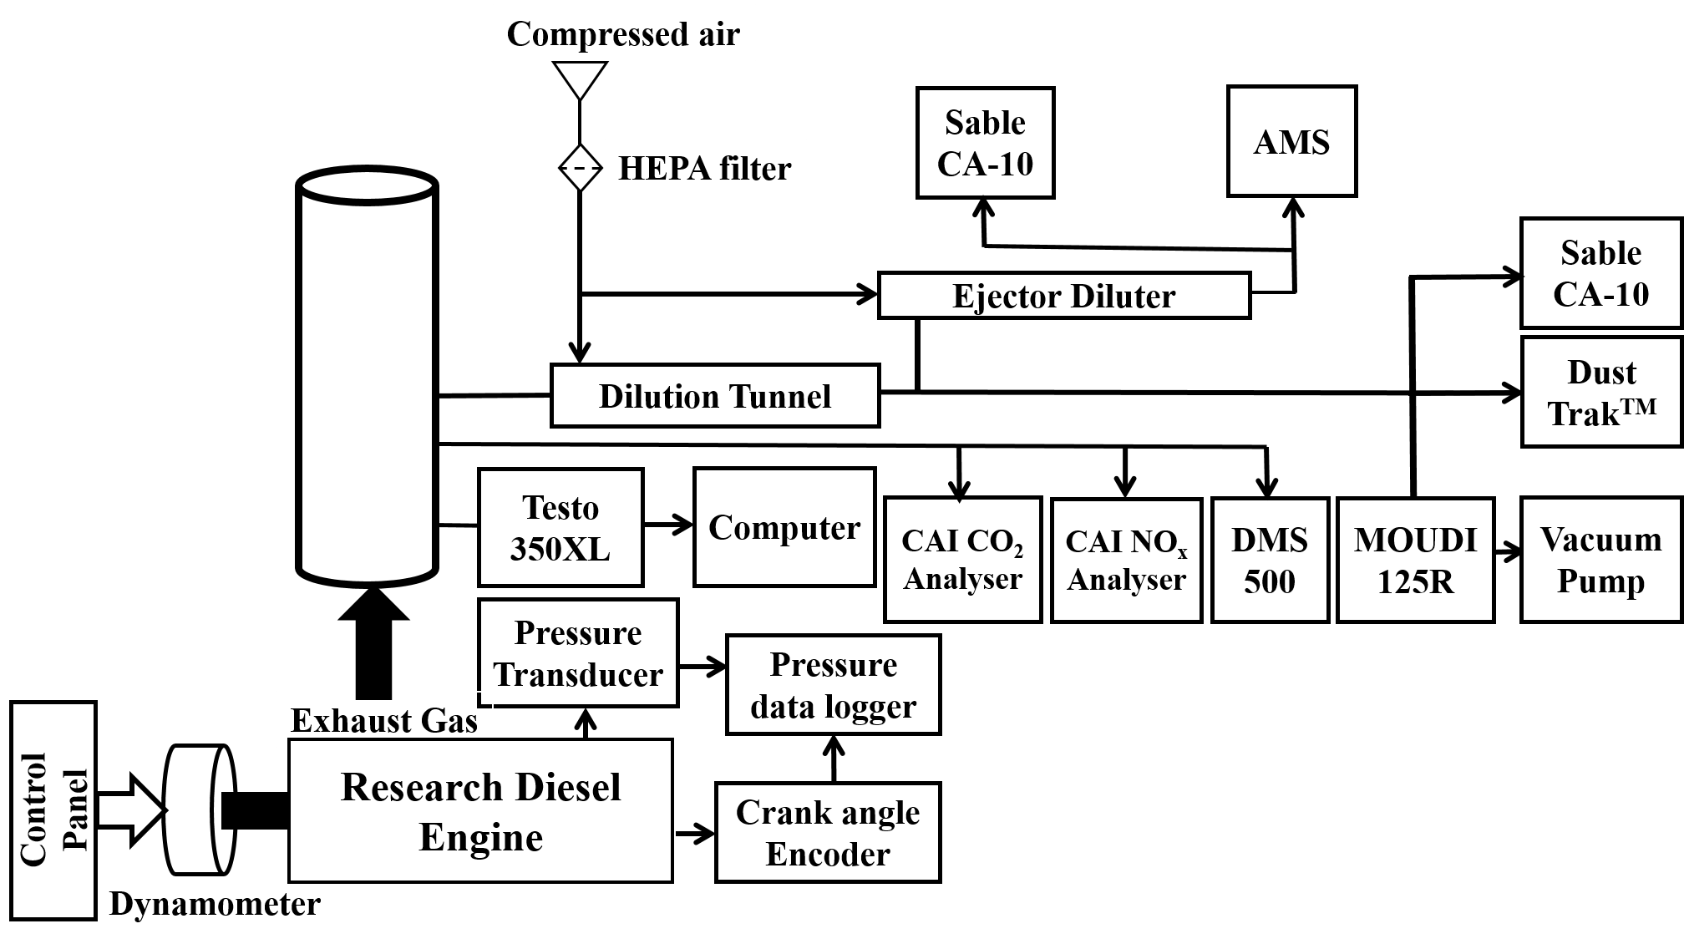

Figure 1: Schematic diagram of test setup

**2.3 Principal Component Analysis**

Principle Component Analysis (PCA) [20] was used as a quantitative tool to explore relationships between the (i) measured engine performance and emissions variables and (ii) fuel S and V content and engine load. In PCA, new variables called Principal Components (PCs) are found which are a linear combination of the existing variables. The PCs are found in such a way that they are mutually orthogonal, with the direction of the first co-ordinate axis capturing the most of the variation in the original dataset *X*. The utility of PCA stems from being able to map a high dimensional space to a low dimensional space, whilst at the same time capturing most of the variance in the original dataset. The algorithm to perform PCA relies on finding the Singular Value Decomposition (SVD) of *X*. The SVD produces two orthogonal matrices (*U* and *VT*) which arise from the left and right singular vectors, as well as a square matrix (*D*) that contains the singular values as given by:

|  |  |
| --- | --- |
| $$X=UDV^{T}.$$ | (1) |

It is possible to decompose *X* into what are called the loadings (*P*) and scores (*T*) matrices via:

|  |  |
| --- | --- |
| $$X=\left(UD\right)V^{T}=TP^{T}.$$ | (2) |

*T* and *P* both have simple interpretations. The loadings matrix captures the contribution of the original variables to a particular PC. Elements of *P* with a higher magnitude indicate that a particular variable strongly influences the resulting PC. Alternatively, the scores matrix provides co-ordinates for data in the new co-ordinate space as found by the PCA. In this study, the number of experimentally measured variables was quite large relative to the number of engine test conditions. This makes PCA a useful technique to perform dimensionality reduction and to promote inferences related to the original experimental dataset. The PCA was performed in RStudio version 1.0.136 using the FactoMineR [21] and psych [22] packages.

**3 Results and Discussion**

The factor loading diagram (Figure 2) indicates the quantitative relationship between variables measured in the engine performance and emissions characterisation and the resulting principal components. Black arrows indicate that the variable is positively correlated with the relevant principal component with red arrows indicating anti-correlation. The absolute value of the factor loading indicates the strength of the correlation. The factor loadings for PC1 are heavily influenced by gas/particle phase emissions of Na and V. The coupled nature of Na/V chemistry in the emissions makes a dominant contribution to PC1 and demonstrates empirical support for corrosive ternary salt formation processes in shipping exhaust.

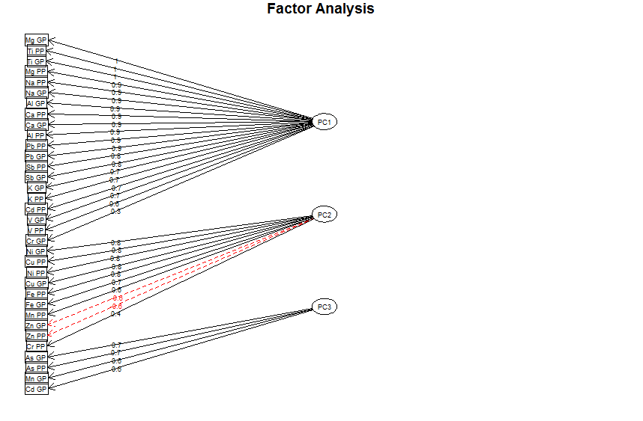Figure 2: Factor loading diagram for the first three principal components (denoted PC1, PC2 or PC3). PP refers to a particle-phase element detected with ICP-MS and GP refers to a gas-phase element.

Scores plots for different fuel S and V contents are presented in Figures 3 and 4, respectively. Figure 3 shows a clear effect of S content in fuels. In particular, zero S contents (black open square) and low S (red filled circle symbols) are close to each other and behave similarly, while high S contents (blue open triangle) behave differently by being much more scattered in the 3-PC directions. A similar trend is observed for the V case and shows a clear V effect (Figure 4). High V contents (5 ppm in red filled circles and 15 ppm in blue open triangle symbols) behave totally differently to un-spiked fuel (0 ppm in open square symbols). From Figures 3 and 4, there the combustion of the spiked fuels leads to different emissions products from elements that are prominent in the lubricating oil (e.g. Ca, Mg).

The loadings plot presented in Figure 5 shows the relationship between variables. Correlated variables lie close to each other in the graph (± 450), anti-correlated variables lie in roughly opposite directions (135-2250), whilst independent or un-correlated variables, lie in a roughly orthogonal direction (45-1350) in the graph. For example, NOx and CO2 variables (both in the red square) located in the top left quadrant of Figure 5 are significantly correlated, while the NOx and SO4_AMS (orange ellipse) variables show a strongly anti-correlated trend. This may be due to higher S levels in the fuel lowering its HHV that may reduce combustion temperature. Consequently, NOx emissions will be reduced.

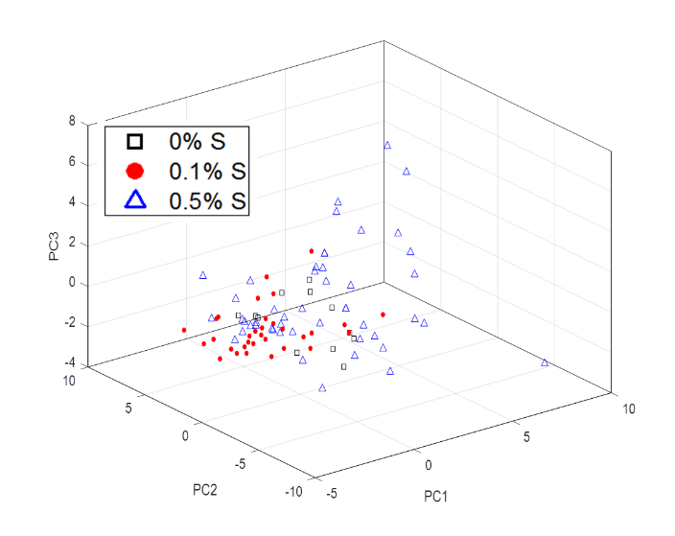

Figure 3: Scores plot for different fuel S contents

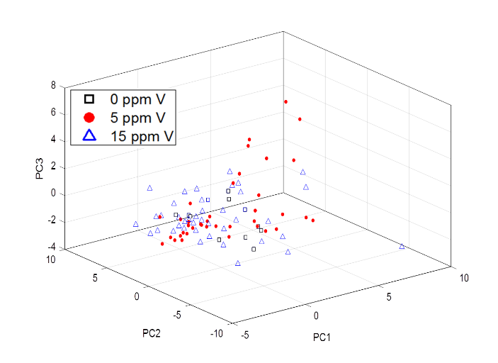Figure 4: Scores plot for different fuel V contents

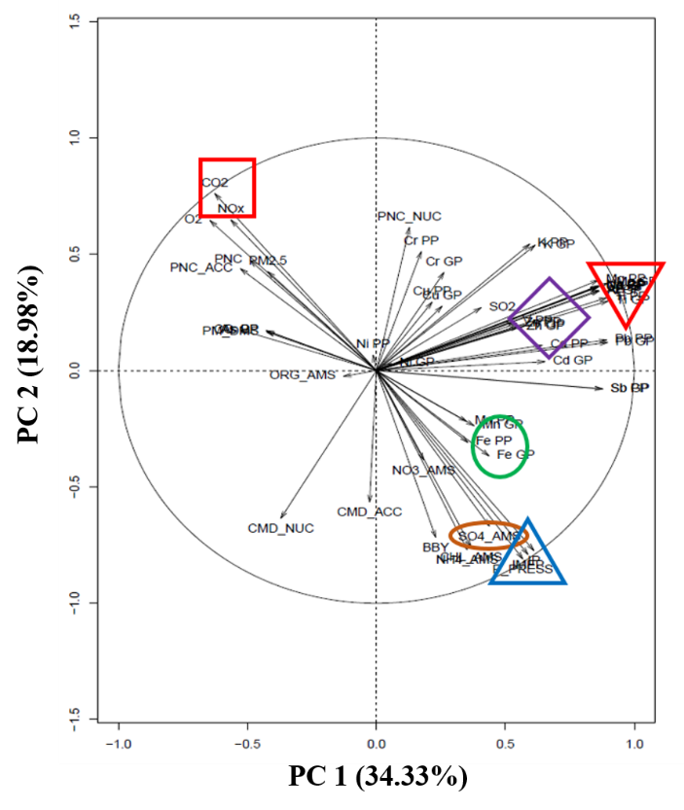 Figure 5: Loadings plot of variables

There is also a trend of increased vanadium content (purple diamond) being closely related to emitted Fe (green circle) and Al (red down triangle) in particles (Figure 5). This may be due to the oxidation attack and corrosion from engine parts caused by the availability of V in fuels used.

It is also clearly evident that higher in-cylinder pressure (higher engine loads) resulted in higher piston ring/liner loadings which can accelerate bore wear rates. Consequently more Fe can be created, so Fe (green circle) is highly correlated to engine pressure (blue up triangle) as presented in the bottom right quadrant of Figure 5.

**4 Conclusions**

This study has presented detailed measurements of gases and particle emissions from a non-marine diesel engine fueled with different S and V spiked fuels. Principal Component Analysis has been applied in this study to explore relationships between the measured engine performance and emissions variables and specific engine test conditions. Results showed that clear S and V effects have been presented by major strong evidences: an increase in SO4, Al and Fe portions of emitted particles. Strong effect of engine loads have been investigated.

**5 Acknowledgment**

The second author gratefully acknowledges the financial support from the Vietnam Government for a PhD scholarship. The authors would also like to acknowledge: the software developer, Mr. Andrew Elder from DynoLog Dynamometer Pty Ltd; laboratory assistance from Mr. Noel Hartnett; QUT staff and colleagues for their support and guidance.

**References**

1. J.J. Corbett, Updated emissions from ocean shipping. Journal of Geophysical Research 108 (D20) (2003).

2. V. Eyring, Emissions from international shipping: 2. Impact of future technologies on scenarios until 2050*.* Journal of Geophysical Research, 110 (D17) (2005).

3. H. Winnes, J. Moldanová, M. Anderson, E. Fridell, On-board measurements of particle emissions from marine engines using fuels with different sulphur content. Proceedings of the Institution of Mechanical Engineers Part M: Journal of Engineering for the Maritime Environment 230 (1) (2016) 45-54.

4. A.A. Reda, J. Schnelle-Kreis, J. Orasche, G. Abbaszade, J. Lintelmann, J.M. Arteaga-Salas, B. Stengel, R. Rabe, H. Harndorf, O. Sippula, T. Streibel, R. Zimmermann, Gas phase carbonyl compounds in ship emissions: Differences between diesel fuel and heavy fuel oil operation. Atmospheric Environment 112 (2015) 370-380.

5. L. Mueller, G. Jakobi, H. Czech, B. Stegel, J. Orasche, J.M. Arteaga-Salas, E. Karg, M. Elsasser, O. Sippula, T. Streibel, J.G. Slowik, A.S.H. Prevot, J. Jokiniemi, R. Rabe, H. Harndorf, B. Michalke, J. Schnelle-Kreis, R. Zimmermann, Characteristics and temporal evolution of particulate emissions from a ship diesel engine. Applied Energy 155 (2015) 204-217.

6. F. Di Natale, C. Carotenuto, Particulate matter in marine diesel engines exhausts: Emissions and control strategies. Transportation Research Part D: Transport and Environment 40 (2015) 166-191.

7. M. Anderson, K. Salo, A.M. Hallquist, E. Fridell, Characterization of particles from a marine engine operating at low loads. Atmospheric Environment 101 (2015) 65-71.

8. J. Blasco, V. Durán-Grados, M. Hampel, J. Moreno-Gutierrez, Towards an integrated environmental risk assessment of emissions from ships' propulsion systems. Environment International 66 (2014) 44-47.

9. Z.D. Ristovski, B. Miljecviv, N.C. Surawski, L. Morawska, K.M. Fong, F. Goh, I.A. Yang, Respiratory health effects of diesel particulate matter. Respirology 17 (2) (2012) 201-212.

10. J.J. Corbett, J.J Winebrake, E.H. Green, P. Kasibhatla, V. Eyring, A. Lauer, Mortality from Ship Emissions: A Global Assessment. Environmental Scinece & Technology 41 (24) (2007) 8512–8518.

11. T. Chu-Van, T. Rainey, Z.D. Ristovski, A.M. Pourkhesalian, V. Garaniya, R. Abbassi, L. Yang, R.J. Brown, Emissions from a marine auxiliary diesel engine at berth using heavy fuel oil, The 10th AHMT Conference, QUT-Brisbane, Australia, 2016.

12. J. Moldanová, E. Fridell, O. Popovicheva, B. Demirdjian, V. Tishkova, A. Faccinetto, C. Focsa, Characterisation of particulate matter and gaseous emissions from a large ship diesel engine. Atmospheric Environment 43 (16) (2009) 2632-2641.

13. H. Agrawal, Q.G.J. Malloy, W.A. Welch, J.W. Miller, D.R. Cocker III, In-use gaseous and particulate matter emissions from a modern ocean going container vessel. Atmospheric Environment 42 (21) (2008) 5504-5510.

14. Vanadium Sulphur in Marine Fuels, the International Bunker Industry Association, available at <http://www.ibia.net/ibia-publications-and-downloads/vanadium-sulphur-in-marine-fuels.pdf>

15. Heavy Fuel Oil, American Bureau of Shipping, available at <http://www.eagle.org/eagleExternalPortalWEB/ShowProperty/BEA%20Repository/Rules&Guides/Current/31_HeavyFuelOil/Pub31_HeavyFuelOil>

16. P. Saiyasitpanich, M. Lu, T.C. Keener, F. Liang, S.J. Khang, The effect of diesel fuel sulfur content on particulate matter emissions for a nonroad diesel generator. Journal of the Air and Waste Management Association 55 (7) (2005) 993-998.

17. H.N. Dunning, J.W. Moore, H. Bieber, R.B. Williams, Porphyrin, Nickel, Vanadium, and Nitrogen in Petroleum. Journal of Chemical & Engineering Data 5 (4) (1960) 546-549.

18. Z-H. Zhang, R. Balasubramanian, Effect of cerium oxide and ferrocence nanoparticles addition as fuel-born catalysts on diesel engine particulate emissions: environmental and heath implications. Environmental Science & Technology, 51 (8) (2017) 4248-4258.

19. A. Zare, M.N. Nabi, T.A. Bodisco, F.M. Hossain, M.M. Rahman, T. Chu-Van, Z.D. Ristovski, R.J. Brown, Diesel engine emissions with oxygenated fuels: A comparative study into cold-start and hot-start operation. Journal of Cleaner Production 162 (2017) 997-1008.

20. R. Wehrens, Chemometrics with R. Multivariate Data Analysis in the Natural Sciences and Life Sciences, Springer, New York, USA, 2011.

21. F. Husson, Multivariate Exploratory Data Analysis and Data Mining, version 1.3.6. 2017.

22. W. Revelle, Procedures for Psychological, Psychometric and Personality Research, version 1.7.5. 2017.