Integrating Social Impact throughout an Engineering Curriculum
Scott Daniel, Llewellyn Mann
Swinburne University of Technology
sdaniel@swin.edu.au

SESSION Integrating Humanitarianism in Engineering Education

CONTEXT The potential that engineering offers of making a positive impact on society motivates many students, yet most university courses only appeal explicitly to this motivation through add-on global experience or service-learning programs. Furthermore, there is an increasing body of research showing that such Social Impact programs lead to improved student outcomes, especially in the development of the professional skill-sets and mind-sets required in the 21st century engineering workforce.

At Swinburne University of Technology, social impact is being integrated and embedded in a new curriculum, co-designed with industry partners, grounded in education research, and built around work-oriented pedagogies including project-based learning. Projects will be aligned with 4 Pillars: Emerging Technologies, Entrepreneurship, research & Development (research in lowercase to indicate the emphasis on Development), and Social Impact. This paper reports on the process of incorporating Social Impact into this new curriculum.

PURPOSE How can Social Impact be integrated throughout an engineering curriculum?

APPROACH Building from an industry co-design process of identifying and unpacking the suite of skills required to succeed and flourish as an engineering graduate, the next stage is developing the curriculum and learning experiences that will enable students to acquire these skills. Within the context of Social Impact, this process involves consulting the education research literature on developing these skills, input from prospective Social Impact project partners, comparison with related project-based and service-learning programs, and then further consultation and validation with industry stakeholders.

RESULTS Several milestones have been reached in developing the Social Impact curriculum pillar. The key aspects distinguishing it from the other pillars have been identified as empathising and communicating with people from diverse backgrounds. A system of micro-credentials will be used as a framework for developing students’ skills, and some of these, such as human-centred design, thinking globally, and embracing diversity, have been mapped to Social Impact. At the time of writing, a Deep Dive curriculum workshop had just been held with industry stakeholders – the outcomes and analysis will be presented at the conference, along with an update on the curriculum development process.

CONCLUSIONS By incorporating lessons learned from other programs around the world, evidence-based teaching strategies from the research literature, and ongoing consultation with prospective project partners and industry stakeholders, Swinburne University of Technology is in the process of developing a world-class new initiative to integrate Social Impact throughout the engineering curriculum.

KEYWORDS curriculum design, social impact, service-learning

Introduction
Swinburne University of Technology (SUT) is developing an innovative practice-based engineering undergraduate degree, with a curriculum co-designed with industry (Cook, Mann, & Daniel, 2017). Rather than the traditional focus on technical content, this new Bachelor of Engineering Practice (Honours) degree will enable graduates to develop the professional skill-sets and mind-sets required in the 21st century engineering workforce. This new project-centric curriculum will have projects aligned to 4 Pillars: Emerging Technologies, Entrepreneurship, research & Development, and Social Impact. The ongoing process of developing a curriculum framework for this last Pillar, Social Impact, is the subject of this paper.

Context

Growth of service-learning and social impact in tertiary education
Service-learning is a recent and growing development in university education. For example, the first research publications only started coming out in the 1990s (e.g. Markus, Howard, and King (1993), but since then multiple journals have been dedicated to this burgeoning area. The International Journal for Service Learning in Engineering: Humanitarian Engineering and Social Entrepreneurship issued its first Volume in 2006, and the Journal of Service-Learning in Higher Education followed suit in 2012.
In engineering, this trend towards addressing social impact can be seen in the rise in recent years of humanitarian engineering education. For example, Engineers without Borders Australia has been running curricular and extra-curricular programs for undergraduate students in this space for more than a decade. Some universities offer humanitarian engineering education research projects or degree specialisations (Amadei & Sandekian, 2010; n.a., 2017a), and now for the first time, the AAEE conference is hosting a session on “integrating humanitarianism in engineering education”.
Addressing social impact is an important trend in engineering education that is being centrally incorporated in the new co-designed curriculum at SUT.

Co-designing a new engineering curriculum with industry
At SUT, the process of co-designing a new curriculum with industry, aligned to university and Engineers Australia requirements, together with input from student focus groups, is well underway. It will be summarised briefly here, as it is has been described in detail elsewhere (Cook et al., 2017).
Its structure has so far entailed two broad stages: stakeholder consultation and consensus building, adapted from the Design your Discipline process (Dowling & Hadgraft, 2013). The industry stakeholder consultation process involved three ideas workshops with more than 60 individuals representing more than 50 diverse engineering employers, who were asked to brainstorm and discuss emerging industry trends, the skills required of future graduates, and more.
Those inputs were analysed and distilled into a draft curriculum framework, successive iterations of which were the subject of two further curriculum development workshops. This consensus building stage involved a total of 21 participants from 18 different organisations giving feedback and input into revising the draft curriculum. At the time of writing, four ‘deep dive’ workshops are being held to plumb the four curriculum pillars one-by-one in detail with industry representatives. The analysis and outcomes of the Social Impact deep dive will be presented at the AAEE Conference in December.
The draft curriculum of the Bachelor of Engineering Practice (Honours) degree is summarised below in Figure 1. It consists of three domains of people, self, and work, complemented by the ‘fundamentals’. Each of the domains of people, self, and work, is divided into three sub-domains. Each of these sub-domains in turn subsumes a number of underlying skills. For example, Communication has been unpacked to include: listening, questioning, adaptive communication style, persuasion & pitching, presentation skills, networking, and writing. Similarly, Management includes project management, risk management, time management, people management & team building, feasibility & prioritising, and budgeting.
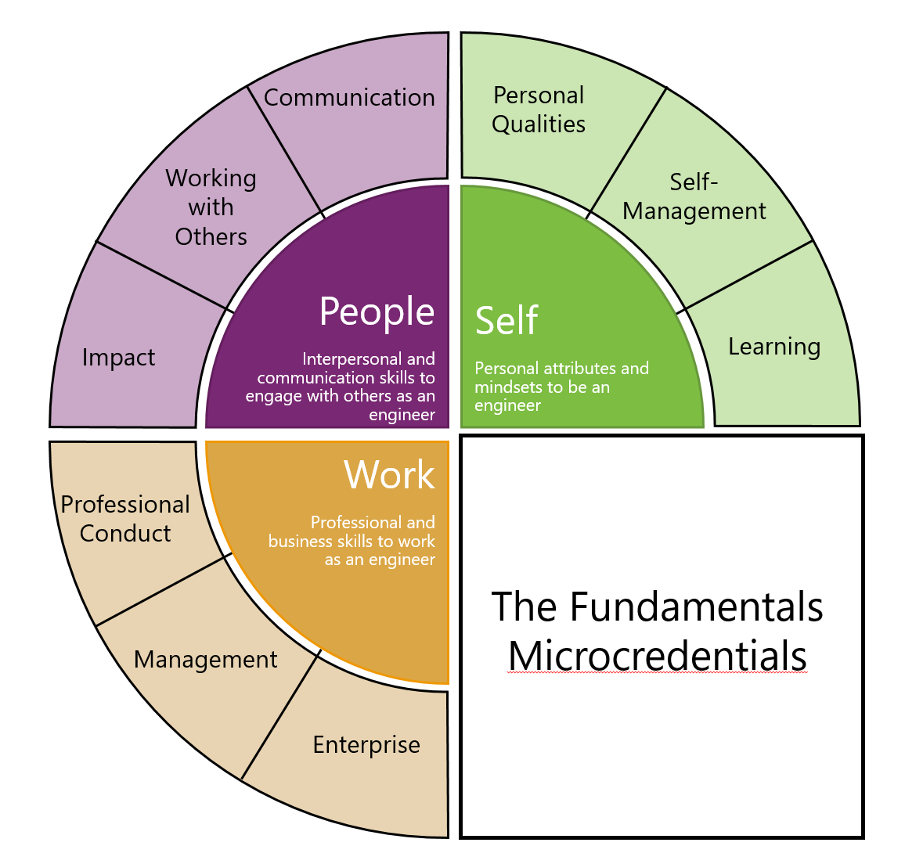
Figure 1: The domains and sub-domains of the draft curriculum

Developing the Social Impact pillar

Inputs and interactions
Apart from input from industry stakeholders, and potentially others such as regulatory or government bodies, the initial and ongoing development of a curriculum and assessment framework for the Social Impact pillar involves a number of inputs and interactions. This includes input from similar programs, feedback loops with industry partners and other ongoing monitoring and evaluation, and engaging with the relevant research literature (see Figure 2). These inputs have been described in detail previously (Daniel & Mann, 2017), and so are only summarised briefly here.
Many service-learning programs in engineering exist at other universities (Bielefeldt et al., 2013). EPICS, at Purdue University, having started in 1995 is perhaps the best known of these, involving inter-disciplinary student teams earning academic credit solving technology-based problems for local community organisations (Oakes, Coyle, & Jamieson, 2000). The Service-Learning Integrated throughout the College of Engineering (SLICE) program at the University of Massachusetts-Lowell has the goal of integrating service-learning into every semester of their engineering degree and so will offer an important comparison point for our own program (Duffy, Barrington, West, Heredia, & Barry, 2011; n.a., 2017b).
Social Impact
Pillar
Similar Programs
Industry Partner Perspectives
Education Research Literature
Evaluation
Figure 2: Inputs and interactions informing the Social Impact Pillar
Working successfully on Social Impact projects will require the development of a number of associated skills, such as engaging community members, human-centred design, working cross-culturally, and more. Many research papers have investigated different teaching strategies to nurture these skills, or developed resources that could be useful for teaching them. For example, Gilbert, Held, Ellzey, Bailey, and Young (2014) reviewed the literature on teaching community engagement skills, whereas Mazzurco and Jesiek (2017) identified five best-practice principles for community engagement - a resource both students and teachers can use in developing skills in this area. In a previous paper (Daniel & Mann, 2017), we reviewed this literature in more detail.
Ongoing monitoring and evaluation of this new program will be key to ensuring the best outcomes. Apart from more typical project-based assessment, there will be regular debriefs with project clients, industry mentors, and students themselves. For Social Impact in particular, there are a number of relevant validated survey instruments, such as those developed to measure attitudes towards sustainability (Hess, Brownell, House, & Dale, 2015), or towards community service (Shiarella, McCarthy, & Tucker, 2000), that will be adapted to evaluate our program.

The Social Impact pillar in the degree framework
Students in the new degree program at SUT will join a functioning practice, the Engineering Practice Academy, on Day 1. Each year of the degree, the student experience will be centred around four 6-week ‘sprints’. Each sprint, students will work in small groups on a project aligned to one of 4 Pillars: Social Impact, Emerging Technologies, research & Development, and Entrepreneurship (Figure 3). Although these projects represent the bulk of the workload, students will also participate in professional development experiences as well as working on a longer-term service learning project.

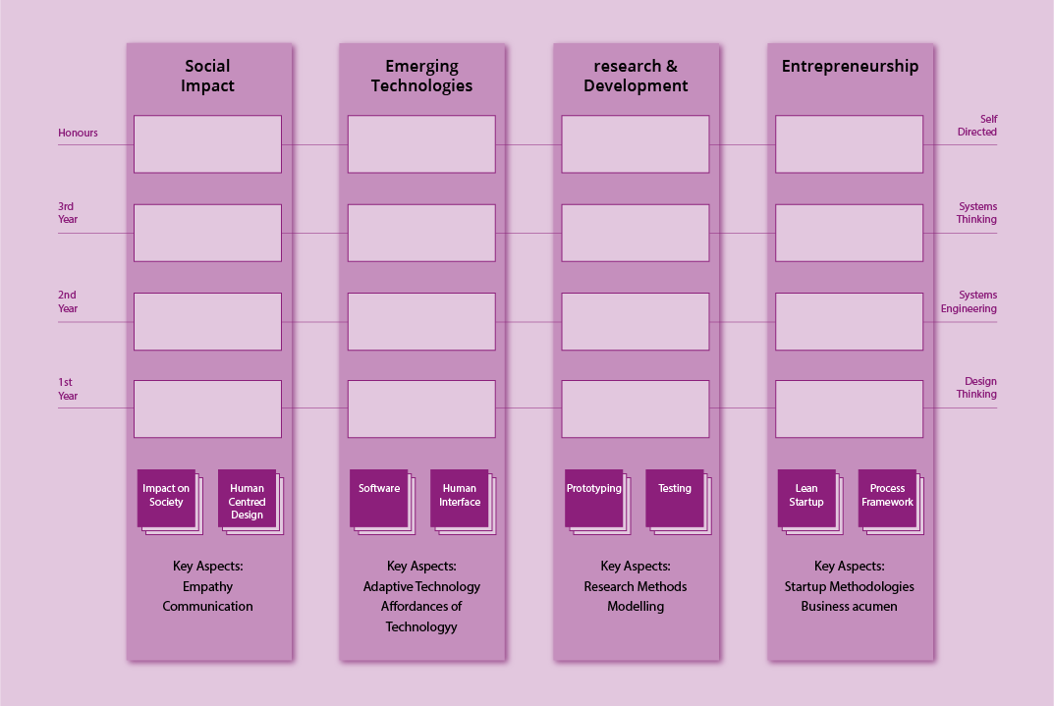
Figure 3: The degree framework of four curriculum pillars

Projects in the different pillars will be distinguished by different key aspects, as indicated at the bottom of Figure 3. The key aspects of the Social Impact pillar are empathy and communication. Empathy is a central component of human-centred design. Social Impact projects will focus on developing students’ ability to empathise with people from a different background from their own. The other key aspect of Social Impact projects will be developing students’ communication skills in diverse contexts. For example, it could be that in a Social Impact project, students will develop and practice the skills to communicate effectively and empathise with members of a rural community to identify a design opportunity, communicate with their teammates in developing their ideas and designs, and then be able to empathise with the perspective of a philanthropic board to so communicate their proposal convincingly enough to win a funding grant.
In the workplace, the ability to communicate and empathise underpin the concepts of psychological safety and collective intelligence in teams, which in turn are key determinants of team effectiveness (n.a., n.d.; Woolley, Chabris, Pentland, Hashmi, & Malone, 2010).

Service-learning versus the Social Impact project
Although each year all students will complete a 6-week social impact team project, they’ll also spend about 10% of their time working on an Academy-wide service learning project. Of course, the service learning project is intended to have a social impact, so the question arises, how is it different to the project within the Social Impact pillar?
There are several key differences. The intended outcome of the Social Impact project is that students develop particular skills, especially regarding their ability to empathise and communicate with people from a different background to their own. It is a contained, short-term project that will be a central component of each students’ performance review, and will effectively involve the student teams conducting R&D for the project client. Conversely, the service-learning project will be on a time-scale of years rather than weeks, and rather than being focused on student learning and assessment, will instead be about producing a tangible outcome for the client.
The first Social Impact pillar project that the initial ‘pathfinder’ cohort in 2018 will work on is the EWB Challenge. The EWB Challenge is an established humanitarian engineering design program for first-year students, now in its tenth year (Jolly, Crosthwaite, & Kavanagh, 2010). It involves student teams from around Australia and overseas developing design solutions for community-based partner organisations in developing countries. The best student designs are shared with the community partner each year. That is, the student teams research and develop ideas and prototypes to address issues faced by the partner organisations and their communities, and so the EWB Challenge is the archetypal Social Impact project.

Micro-credentials underpinning the Social Impact pillar
One task in developing the new degree program has been reconciling the curriculum co-designed with industry (Figure 1) with the university framework of two semesters split into four sprints (Figure 3). To facilitate this process, we physically printed each curriculum point on a separate slip of paper and then had a robust and interactive discussion to map them to the different pillars. A snapshot of this process is shown below in Figure 4.
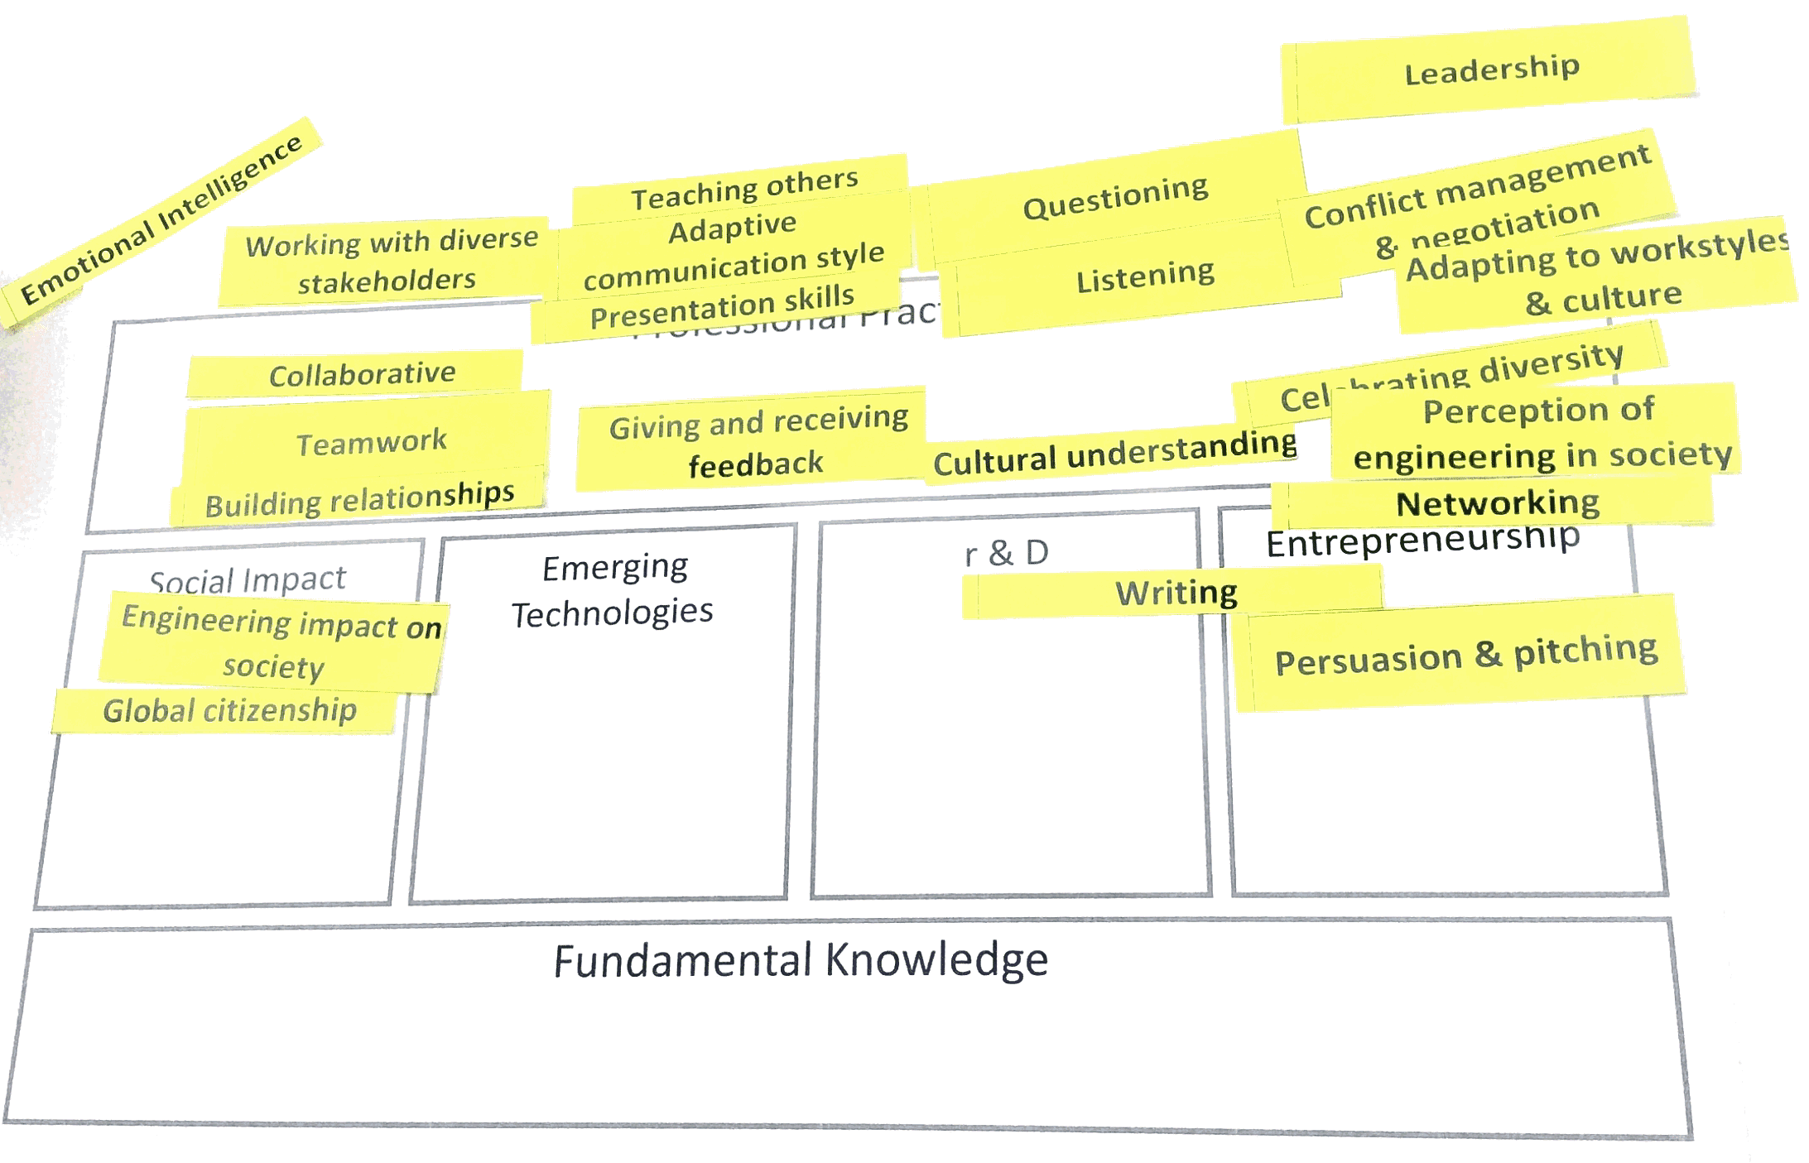
Figure 4: The process of mapping the People curriculum domain to the different Pillars
The outcome of this process was matching the following six points to the Social Impact pillar: Global Citizenship, Engineering impact on society, Problem scoping, Empathy, Personal ethics, and Sustainability and Life-cycle analysis. Students will develop proficiency in these areas under a system of micro-credentials, with incremental milestones leading up to graduate-level expertise.

Social Impact curriculum deep dive with industry
As a further input to the development of the Social Impact pillar, a dedicated workshop was held with industry representatives. The workshop involved participants discussing the meaning of social impact in engineering, and associated skills, knowledge, and attitudes. Participants also discussed the processes and issues involved in understanding the social impact of new designs and industry projects.
Some of the skills identified include emotional intelligence, self-awareness, and good questioning, which resonate with the key aspects of the Social Impact pillar: empathy and communication. Challenges identified with social impact include understanding the broader context of a project (e.g. social, political, historical, etc.), environmental impacts, financial concerns, and health and safety issues. Developing a curriculum and student experience to equip students with the skills to meet these challenges in the workplace is an ongoing focus in the continued development of the new degree program.

Conclusion
The new Bachelor of Engineering Practice (Honours) degree at Swinburne University of Technology is an exciting development in engineering education, doing away with outmoded traditional approaches to instruction, and in their place co-designing a new curriculum centred on work-oriented pedagogies and grounded in education research. Social Impact is one of four Pillars of project-based learning that will comprise a key aspect of the student learning experience.
In this paper, the ongoing process of integrating Social Impact into this curriculum has been described. An update of this process will be presented at the AAEE conference in December.

References

