Published 2 October 2023 · Aboriginal Australia

The use and abuse of History in the Voice referendum debate: an interview with Professor Gary Foley
Gary Foley and Padraic Gibson
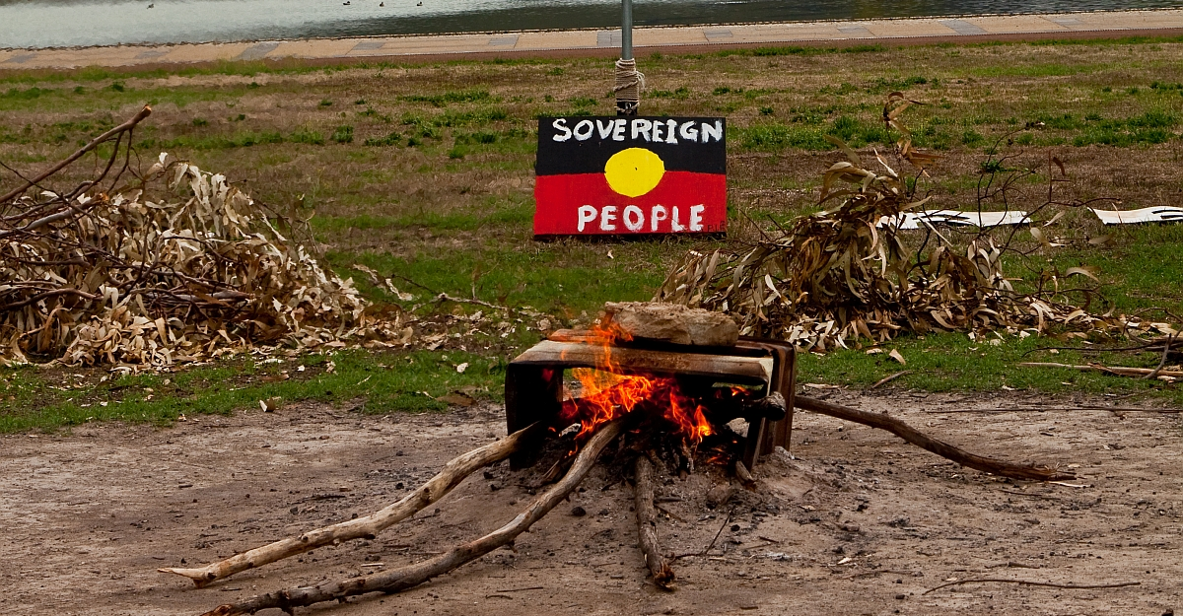

Padraic Gibson: The narrative both in marketing material and speeches from the Voice campaign casts the referendum as the next step forward, or even in some cases the culmination of a very long struggle for justice and self-determination that you’ve been an important part of. The main slogan of the campaign is ‘History is Calling’ and we are told that a Yes vote is about being ‘on the right side of History’. Could you share your thoughts on the place of this referendum in the History of the struggle for Aboriginal rights?

Gary Foley: How anybody could conceive of this as some form of culmination of the struggle for self-determination, or say that ‘History is calling’ here is ludicrous. There is no self-determination element in this proposition whatsoever.
Most of the talk I’ve heard on both sides of the argument is a total misrepresentation of the past. The Voice is simply yet another Aboriginal advisory body. And we’ve got a long history, at least a fifty-year history, of Aboriginal advisory bodies. The very first Aboriginal advisory body set up by the Federal Government consisted of three white men, Anthrophologist Bill Stanner, Economist Nugget Coombs and former Australian Ambassador to Laos Barry Dexter.
It wasn’t until Whitlam came along that we actually got an elected, national representative advisory body. Then, when Whitlam got turfed, Malcolm Fraser created his own version of an Aboriginal advisory body. Then along comes the Hawke government, and they create their version of an Aboriginal advisory body, this time with a limited capacity to make some decisions on a little bit of funding.
But of all the advisory bodies that ever existed, the one thing they’ve all got in common is that no government ever took the slightest bit of notice of any of them. That’s because governments weren’t obliged to take notice of them, because they were merely advisory. And that’s the case whether it’s enshrined in the constitution or not.
Every one of these previous, numerous Aboriginal advisory bodies, you didn’t need a referendum to set them up, governments simply legislated for each of their versions. So, why do we need a referendum?
People say — it’s to enshrine it in the Constitution. Well, that’s a bit of a problem. Because what if this advisory body turns out to be a dud like all the rest of them? We’re stuck with it into eternity because getting rid of it is going to be almost impossible.

Padraic Gibson: The constitutional amendment we are being asked to vote on specifies that the parliament will determine its functions, its structure, its composition, everything about it. The government could scrap the body and reconstitute one more to their liking, just as they have before.

Gary Foley: All that strengthens my argument that this is not self-determination. It could turn out that it’s not the government that wants to get rid of the body, it might be us, and we will not have the capacity to get rid of the damn thing if it does, as I predict, turn out to be another dud, in the sense that the government will not heed the advice it gives if it’s unpalatable. The government isn’t obliged to take any notice of it at all.
So, at the end of the day, it’s nothing new, and nothing to get excited about. I can’t really see any good reason to either vote yes, or to vote no. The whole exercise is just yet another effort to put a bit of lipstick on the pig. It’s yet another device to divert the people from the real issues of self-determination, economic and political independence, which have been the consistent Aboriginal political demands since the first modern day Aboriginal political organisation, the AAPA, in the 1920s.
The whole idea of having a referendum on an Aboriginal issue in the year 2023, the nicest thing I could say about it is that it was ill-conceived in the first place. Because this is not Australia, 1967, anymore. This is Australia that has been subjected to forty years of history and culture wars, Pauline Hanson and One Nation, Sky After Dark, the Murdoch tabloids, all of which has contributed to this being a far more polarised nation at this point in its history.
And for anyone to think that a question on something to do with Aborigines in a Federal Referendum had a snowballs chance in hell of getting up at this point in history, knows nothing about History. It was a stupid idea, ill-conceived and not an idea that emerged from the grassroots of Aboriginal Australia.

Padraic Gibson: Can you talk about the concept of constitutional recognition? What is your attitude to this idea and where did it come from historically?

Gary Foley: Why would I, as, as member of the Gumbaynggirr nation, who have never ceded our sovereignty, why would I want anything about me in the constitution of a foreign country? Why would we hook our trailer to a disreputable nation like Australia? That’s the simple answer for me, I’m not interested in constitutional recognition, I don’t think that anybody with any sense should be talking about it.
If we understand our history, the first of the emerging Black middle class began in the period of the Whitlam government, when the Whitlam government began astutely recruiting into the ranks of the public service, some of the people who they thought were future leaders. In doing so, they gave them a different perspective to that of the political activists still on the outside. The ideas that you’re talking about have emerged from the newly minted Black middle class, rather than the Black grassroots of Australia.
What you are seeing is a replication of the process that evolved in the USA, where once you had a Black middle class, then you had a group of people that the power structures could deal with and negotiate with and reach compromises with, undercutting the vast Black underclass in the United States. A similar phenomenon has happened here, only in much more recent times than it occurred in America.
The broader ignorance of where this referendum fits into history is reflected in the reverence displayed for the Uluru statement. I mean, the Uluru statement was made by a fairly selective bunch of Indigenous leaders, some of them so-called leaders. Gathering at such as symbolic place as Uluru was designed to give unwarranted meaning to this assembly. Some sort of psychic or spiritual blessing. It elevated the statement into some sort of sermon from the mount or something.
By no means was this group representative of opinion in Aboriginal communities across Australia. Their position shouldn’t be seen as more important than the strong opposition to such a notion of a referendum expressed amongst Victorian Aboriginal communities. Most Aboriginal communities across Australia would have had no idea about this proposal for a referendum, or being inserted into the constitution.
The other thing with this referendum is that once again, our future as Aboriginal people is in the hands of a vast, white, largely unsympathetic electorate. White people, yet again, are deciding what is best for Aboriginal people. This is exactly the opposite of self-determination.

Padraic Gibson: The 1967 referendum looms very large as well in the current referendum campaign as a moment of profound change, that people are trying to replicate in some way and take forward. What historical lessons do you think should be drawn from the 1967 referendum?

Gary Foley: Well, any claims about the history of the 1967 referendum along the lines of the statements you’ve just made is a reflection of the falsification or distortion of recent history by recent Australian historians, creating the perception out there that the 1967 referendum was some big, meaningful moment for Aboriginal people.
The most significant thing that came out of the 1967 referendum was the historic size of Yes, which caught everybody by surprise. It was thought to be, at the moment it happened, a definitive assertion on the part of the Australian people — over 90 per cent — that they believed in justice for Aborigines, and that something should be done about it. It was their instructions, if you like, to the governments of the day.
And what did the governments of the day do? Well, the Federal government largely ignored it. They set up their first little Aboriginal advisory group, and as I said this consisted of three white men. But other than that, once John Gorton took over from Harold Holt as Prime Minister in the immediate aftermath of the referendum, he told Barry Dexter that he hated Aboriginal people, didn’t want to do anything for them, took the three men I mentioned, kicked them out of the Prime Minister’s Department and never had any communication with them from then on.
However, in New South Wales, in a fit of pique if you like, the state government suddenly decided to arbitrarily shut down the old Welfare Board system, the old apartheid system. This happened overnight, without any reference to what might happen to those thousands of Aboriginal people still on those reserves they ran in the rural areas. That created great social disruption. There was a vast exodus from the rural areas into Sydney, of people seeking employment to be able to survive. So in NSW, things actually became far worse as a result of the referendum than they did better.
The older generation of Aboriginal political leaders had given assurances to the younger generation at the time of the referendum that if we, as younger people, joined them in the campaign to get a Yes vote then things would change for the better. Well, things didn’t change for the better, and it was as a result of that, that the younger generation developed a disaffection with the older generations strategies and tactics. That led directly to the emergence of a creature that some called the Black Power movement, some called the self-determination movement, others called the Land Rights movement. These were one and the same thing, but that emerged as a direct result of the failure of the 1967 referendum to deliver any real change. The younger generation decided that self-determination meant that we had to go out and sort things out for ourselves.
Self-determination means Aboriginal control of Aboriginal Affairs. It means political and economic independence. And that’s what sovereignty means.

Padraic Gibson: Gunaikurnai writer Ben Abbatangelo has been saying that if this referendum fails, then that has to be used to regenerate struggle built around a rights-based agenda. There is certainly a concern though, that a big No vote could lead to demoralisation, a belief that there’s not support out there for Aboriginal people and the fight for Aboriginal rights.

Gary Foley: I’d reassure you by saying, don’t worry. I can see the failure of the referendum making a whole lot of Blackfellas sit up and think and realise again, what we realised back in ’67, that our best efforts to achieve our aims are always at our own behest, under our own control. A whole new generation of Black activists deciding hang on, to hell with the rest of them, let’s just focus on our own communities and start building up the strength of our own communities. In just five years after the ’67 referendum, we managed to build up a movement that changed the course of Australian history at the Aboriginal Embassy, drew massive national support and internationally, for the first time the world because aware of the struggle for justice in Australia.
Great things happened in Aboriginal communities — the creation of independent Aboriginal community-controlled health services, legal services, housing co-operatives, all these things flourished in the aftermath of the referendum. It was only when the Hawke Labor government came along that the final suppression of that strong self-determination of the self-determination movement began in earnest. Governments of all political persuasions, the worst being Labor governments, have worked overtime to undermine and destroy the local community controlled Aboriginal organisations, to control the old self-determination movement and turn it around, so that they appropriated even the language they talk about self-determination.
The self-determination they talk about is certainly not the self-determination we were talking about fifty years ago. It’s a distorted view.

