Investigation of the effect of heated ethanol fuel on combustion and emissions of an ethanol direct injection plus gasoline port injection (EDI+GPI) engine
Yuhan Huang *, Guang Hong
Affiliation:
School of Electrical, Mechanical and Mechatronic Systems, University of Technology Sydney, Sydney, Australia
Corresponding author:
Yuhan Huang, PhD student
Postal address: School of Electrical, Mechanical and Mechatronic Systems, University of Technology Sydney, PO Box 123, Broadway NSW 2007, Australia
Email: Yuhan.Huang@student.uts.edu.au
Telephone: +61 415040942

Abstract
Ethanol direct injection plus gasoline port injection (EDI+GPI) is a new technology to utilise ethanol fuel more efficiently and flexibly in spark ignition engines. One issue needs to be addressed in the development of EDI+GPI is the ethanol fuel’s low vapour pressure and large latent heat which slow down the ethanol’s evaporation and result in the mixture unready for combustion by the time of spark ignition and the consequent increase of CO and HC emissions. Heating the ethanol fuel to be directly injected (EDI heating) has been proposed to address this issue. This paper reports the investigation of the effect of EDI heating on the combustion and emissions of a research engine equipped with EDI+GPI. The results showed that EDI heating effectively reduced the CO and HC emissions of the engine due to the increase of evaporation rate and reduced fuel impingement and local over-cooling. The reduction of CO and HC became more significant with the increase of ethanol ratio. When the temperature of the ethanol fuel was increased by 40 ℃, the CO and HC were reduced by as much as 43% and 51% respectively in EDI only condition at the original spark timing of 15 CAD BTDC, and 15% and 47% respectively at the minimum spark advance for best torque (MBT) timing of 19 CAD BTDC. On the other hand, the NO emission was slightly increased, but still much smaller than that in GPI only condition due to the strong cooling effect and low combustion temperature of EDI. The IMEP and combustion speed were slightly reduced by EDI heating due to the decrease of injector fuel flow rate and spray collapse of flash-boiling. The largest decrease of IMEP was 5% at the original spark timing and 3% at the MBT timing. Moreover, at the MBT timing, the IMEP increased continuously with the increase of ethanol ratio in the entire range from 0% to 100%. This indicated that the decrease of IMEP in high ethanol ratio conditions at the original spark timing could be avoided by adjusting the spark timing. Therefore EDI heating is effective to address the issues of ethanol’s low evaporation rate in low temperature engine environment and over-cooling effect at high ethanol ratio condition in the development of EDI+GPI engine.

Keywords
Ethanol direct injection; Gasoline port injection; Heated ethanol fuel; Flash-boiling; Combustion; Emissions

Highlights
- Effect of EDI heating on the EDI+GPI engine performance was investigated.
- CO and HC were significantly reduced and NO was slightly increased by EDI heating.
- IMEP and combustion speed were slightly reduced by EDI heating.
- EDI heating is effective to address the evaporation and over-cooling issues of EDI+GPI engine.

Abbreviations
BTDC: Before top dead centre
CAD: Crank angle degrees
EDI: Ethanol direct injection
EDI+GPI: Ethanol direct injection plus gasoline port injection
E’X’: X% ethanol by volume (e.g. E40 is 40% ethanol by direct injection + 60% gasoline by port injection)
GPI: Gasoline port injection
HRR: Heat release rate
IMEP: Indicated mean effective pressure
MBT: Minimum spark advance for best torque
SI: Spark ignition

Introduction
The increasing concern for the fossil fuel depletion and global warming has become the driving force for searching renewable fuels . Among the current renewable fuels, ethanol is a promising and widely used alternative fuel for internal combustion engines . Ethanol direct injection plus gasoline port injection (EDI+GPI) is a new technology to utilise ethanol fuel more efficiently and flexibly in spark ignition (SI) engines than E10 or E85 in the current market . It integrates the advantages of both port injection and direct injection fuel systems. Dual-injection concept offers the flexibility to change the fuel ratio to optimize the engine performance. The GPI plays a role in addressing the cold start issue of ethanol fuel due to ethanol’s low volatility and large latent heat of vaporization . It is reported that gasoline-fuelled engines could be started at ambient temperature as low as -40 ℃, while ethanol fuelled engines could not be started at temperature lower than 13 ℃ without an auxiliary cold start system . The EDI can be started once the engine is warmed up and the percentage of ethanol fuel can be increased with increased engine load to suppress the knock propensity by taking the advantages of strong cooling effect of EDI and ethanol’s high octane number. By doing so, the engine thermal efficiency can be increased by increasing the compression ratio and using turbocharging technology whilst avoiding the knock issue in downsized engines. The newly released Toyota D-4S engine has increased the compression ratio to 12.7 by using a dual-injection system of gasoline port injection and direct injection in production cars .
Dual-injection represents an advanced combustion control strategy for both spark-ignition (e.g. EDI+GPI for knock onset control ) and compression-ignition (e.g. Reactivity Controlled Compression Ignition (RCCI) for auto-ignition control ) engines. The application of dual-injection in SI engines was firstly proposed by Cohn et al. . By direct injection of ethanol fuel in a gasoline port injection engine, the thermal efficiency could be greatly increased by implementing engine downsizing technologies (e.g., high compression ratio, turbocharging and more spark advance) while avoiding the knock issue. To exploit the potential of the ethanol fuel in increasing the compression ratio and engine thermal efficiency, a single cylinder SI engine equipped with EDI+GPI has been developed . Experimental results showed that the engine thermal efficiency was increased and knock propensity was reduced when EDI was applied. However, the HC and CO emissions of the engine were increased with the increase of ethanol ratio . Numerical investigation to the EDI+GPI engine found that the slow evaporation rate of ethanol fuel might have resulted in poor mixing and thus the increased HC and CO emissions . Experimental and numerical studies showed that the ethanol fuel evaporated slowly when the fuel temperature was equal to or lower than 375 K, but evaporated quickly when the temperature was higher than 375 K . Therefore, heating the ethanol fuel to be injected directly (EDI heating) was proposed to address the slow evaporation and poor mixing issues in the EDI+GPI engine .
The mixing and evaporating processes of a liquid fuel spray can be affected by a number of factors. To achieve fast evaporation and mixing in direct injection SI engines, the most widely adopted strategy is high pressure injection which generates very fine droplets and thus makes it possible for the liquid fuel to evaporate in tens of crank angle degrees. However, the benefits brought by the high pressure injection are limited. The high injection pressure may cause fuel impingement on the cylinder and piston walls, especially in downsized engines. On the other hand, the droplet size reduced by increasing injection pressure is limited by the injection pressure in a medium range . Fuel temperature is also an important factor that affects the droplet size and evaporation rate of a liquid fuel. Increasing the fuel temperature is an effective way to reduce the viscosity and increase the vapour pressure of the fuel, and consequently increase the break-up and evaporation rates. Since ethanol fuel has larger viscosity and surface tension than that of gasoline, E85 shows larger Sauter Mean Diameter (SMD) than gasoline does. With the increase of fuel temperature, the SMD reduces and the difference in E85 and gasoline’s SMDs becomes small when the temperature is sufficiently high . Particularly, when the fuel temperature is higher than its boiling point, vapour bubbles may form inside a droplet and burst into smaller ones . It is reported that the SMD of the spray droplets showed a rapid reduction when flash-boiling occurred . Moreover, the vapour pressure of ethanol fuel is lower than that of gasoline fuel when the fuel temperature is lower than 375 K but higher when the fuel temperature is higher than 375 K. As a result, ethanol evaporates more slowly than gasoline does in low temperature condition, but they reach the similar evaporation rates when the fuel temperature is higher than 375 K . Xu. et al. proposed using flash-boiling to generate fine droplets as an alternative and economic method for high pressure injection. Investigation showed that the evaporation rate of a spray could be significantly enhanced in flash-boiling conditions .
Nwafor investigated the combustion and emission performance of a diesel engine fuelled with elevated fuel temperature of neat vegetable oil. The effect of fuel temperature on the performance of a diesel engine fuelled with rapeseed methyl ester (RME) fuel was investigated . Kabasin et al. investigated the cold start performance of ethanol-fuelled SI engines equipped with heated injectors. The engine cold start time was reduced and the HC and CO emissions were significantly decreased when the fuel was heated. Sales and Sodré investigated the cold start combustion and emission characteristics of a flexible fuel engine with heated intake air and ethanol fuel. By heating the intake air and the ethanol fuel, their results showed that the ethanol fuelled engine could be started at cold ambient temperature of 0 ℃ and with significant reduction in HC and CO emissions.
As reviewed above, increasing the fuel temperature could be an effective and economic way to generate fine and fast evaporation sprays and to improve the performance of ethanol fuelled engines in cold start conditions. However, so far, rare work has been reported on investigating the engine performance with heated ethanol fuel at warmed up conditions. To address the emission issues in the current EDI+GPI engine, experiments were conducted to investigate the effect of EDI heating on improving the combustion and emissions of an SI engine equipped with EDI+GPI dual-injection system.

Experimental Apparatus and Procedures
  - EDI+GPI engine test rig
The experiments were conducted on a single-cylinder four-stroke air-cooled SI engine equipped with a direct injection system for injecting ethanol fuel and a port injection system for injecting gasoline fuel. Fig. 1 shows the schematic of the engine test rig. Table 1 provides the specifications of the engine which was originally a port fuel injection engine used on the Yamaha YBR250 motorcycle. The engine was modified to be an EDI+GPI engine by adding an EDI fuel system to the engine. The EDI injector was a six-hole injector with a nozzle diameter of 110 um. The spray cone angle is 34° and the bent angle is 17°. The GPI injector was the original port fuel injector used in the Yamaha YBR250 motorcycle. The EDI injector was mounted with the spray plumes bent towards the spark plug to create an ignitable mixture around the spark plug. The tip of the injector was placed 15 mm to the spark plug on the intake valve side. Both the GPI injector and EDI injector were controlled by an electronic control unit (ECU). The EDI+GPI fuel system offers the flexibility to operate the engine over a full range of ethanol ratio from 0% (GPI only) to 100% (EDI only). More information about the engine test rig can be found in .
An electric resistance heater made of Kanthal A1 heating resistance wire was used to heat the ethanol fuel in the high pressure fuel rail, as shown in Fig. 1. The wire was wrapped on the fuel rail upstream the injector. A T-type thermocouple was attached on the surface of the fuel rail at the entrance of the EDI injector to measure the ethanol fuel temperature. The temperature was fed back to a 2132 Eurotherm PID temperature controller which controlled the relay of the heating system so that the heating process was stopped when the fuel temperature reached the required value. The fuel rail temperature at the injector entrance was regarded as the fuel temperature in the present study. The accuracy of the temperature control was within ±3 ℃.
The mass flow rate of the intake air was measured with a ToCeil-20N hot-wire thermal flow meter. The engine speed was controlled by an eddy current DC dynamometer. The in-cylinder pressure was measured by a Kistler 6115B measuring spark plug pressure transducer at a resolution of 0.5 crank angle degree. A hundred consecutive cycles of pressure were recorded. The exhaust gas emissions were measured using a Horiba MEXA-584 L gas analyzer. The Horiba MEXA-584L gas analyzer can measure the lambda (excess air ratio) of multiple fuels with H/C and O/C atomic ratios of the fuel input by the user. In the present study, the lambda was monitored and kept around one by adjusting the mass flow rates of the gasoline and ethanol fuels at a designated fuel ratio and a fixed throttle position. The gasoline and ethanol fuel mass flow rates were input to the ECU. The calibration of the EDI injector was provided by the ECU supplier, Hents Technologies Inc. The EDI injection pressure was controlled by the ECU and the solenoid valve in the high pressure pump.

Test fuels
Table 2 provides the main properties of gasoline and ethanol fuels used in the present study. The gasoline fuel was the Unleaded Petrol (ULP) from the Caltex Australia with an octane number of 91. The ethanol fuel was provided by the Manildra Group.

Experimental procedures
The engine was started and warmed up by gasoline port injection only. The experiments were conducted when the engine body temperature became stable at around 200 ℃. Then the amount of gasoline was reduced and the ethanol fuel was directly injected into the cylinder to substitute gasoline. Table 3 lists the engine conditions investigated in the present study. The experiments were conducted at medium load (IMEP 6.0~6.5 bar). The tested engine speeds were 3500 and 4000 rpm. In all the tests, the lambda was kept around one. The GPI pressure was 0.25 MPa and the EDI pressure was 4 MPa. The GPI timing was 410 CAD BTDC and EDI timing was 300 CAD BTDC. The ethanol ratio started at E0 and then varied from E25 to E100 with an increment of 15% (E’X’ means X% ethanol by volume. e.g. E40 means 40% ethanol by direct injection plus 60% gasoline by port injection). Firstly the experiments were conducted to compare the engine performance with and without EDI heating at the engine original spark timing of 15 CAD BTDC. The results showed significant reduction of engine emissions but slightly decreased indicated mean effective pressure (IMEP). To recover the IMEP, the effect of EDI heating on engine combustion and emissions was also investigated at the minimum spark advance for best torque (MBT) timing of 19 CAD BTDC. The experiments were firstly performed without the EDI heating system. The measured ethanol temperature was around 50℃ (±2℃). Then the EDI heating system was applied to heat the ethanol fuel to 70 ℃ and 90 ℃. The power required for EDI heating was dependent on the fuel flow rate and the heating temperature. The maximum heating power was about 150 W at E100, 90 ℃ and 4000 rpm condition, which was about 3% of the engine output power. However, the heater only worked intermittently at this power and the power required was much smaller in lower ethanol ratio conditions. In production engines, the heating energy can be taken from the high-temperature exhaust gas (~400℃ in the present study) and thus eliminate the parasitic load of the heating element in the present experiments.
To ensure the accuracy of the results, five samples were recorded at each tested engine condition. The maximum standard deviation of the measurements were 5% for ISCO, 3% for ISNO, 5% for ISHC and 1% for lambda, which indicated acceptable quality of the experimental data and justified the use of averaged sample data in the present study.

Results and Discussion
The experimental results will be presented and discussed as follows. Sections 3.1 reports the effect of EDI heating on the engine performance represented by IMEP and emissions of CO, HC and NO at the original engine spark timing of 15 CAD BTDC. In Section 3.2, the combustion characteristics will be discussed to analyse the causes of the results at the original spark timing. Section 3.3 will focus on the enhanced effect of EDI heating by adjusting the spark timing to the MBT timing of 19 CAD BTDC.

Effect of EDI heating on engine performance at the original spark timing
Fig. 2 shows the effect of ethanol fuel temperature on the IMEP of the EDI+GPI engine at different ethanol ratios and engine speeds. The spark timing was 15 CAD BTDC which was the timing set for GPI only in the original engine control unit. As shown in Fig. 2, the IMEP increases with the increase of ethanol ratio from 0% to 70% without EDI heating, resulting from the effective charge cooling effect and faster combustion speed of ethanol fuel. However, the IMEP decreases when the ethanol ratio is further increased from 70% to 100%. This is because the mixture becomes over-lean around the spark plug, and local over-cooling and severe fuel impingement occur at high ethanol ratios . When the ethanol fuel temperature is increased from 50 ℃ to 70 ℃, the IMEP decreases slightly at each ethanol ratio. It decreases noticeably at high ethanol ratios when the ethanol fuel temperature reaches 90 ℃. The maximum reduction of IMEP at 3500 rpm is 2.2% at fuel temperature of 70 ℃ and 4.5% at 90 ℃ when the ethanol ratio is 70%. The maximum reduction of IMEP at 4000 rpm is 2.2% at 70 ℃ and 5.4% at 90 ℃ at the ethanol ratio of 70%. This is caused by the decrease of the combustion speed when the ethanol fuel is heated, which will be discussed referring to Fig. 7. Fig. 3 shows the effect of ethanol fuel temperature on the indicated thermal efficiency. In the present study, the lambda was kept around one. As the air-fuel ratio of ethanol is 9.0 and that of gasoline is 14.8, 64% more mass of ethanol is injected to replace the reduced mass of gasoline fuel in order to keep the lambda at one. On the other hand, the heating value of gasoline fuel (42.9 MJ/kg) is 59% higher than that of ethanol fuel (26.9 MJ/kg). This indicates that the total energy input at each ethanol ratio condition is close to that of GPI only condition. Consequently, the effect of ethanol fuel temperature on the indicated thermal efficiency shows the same tendencies as that of IMEP in Fig. 2. As shown in Fig. 3, the thermal efficiency increases with the increase of ethanol ratio from 0% to 70% without EDI heating, but decreases when the ethanol ratio is further increased from 70% to 100%. When EDI heating is applied, the thermal efficiency decreases slightly at ethanol fuel temperature of 70 ℃ and decreases noticeably at 90 ℃.
Figs. 4 and 5 show significant reduction of indicated specific carbon monoxide (ISCO) and hydrocarbon (ISHC) emissions with EDI heating. As shown in Figs. 4 and 5, without EDI heating, both the ISCO and ISHC emissions increase with the increase of ethanol ratio due to the incomplete combustion caused by ethanol’s poor evaporation, local over-cooling and fuel impingement of EDI . When the ethanol fuel is heated, both ISCO and ISHC emissions are reduced significantly, and this reduction is enhanced with the increase of ethanol ratio. Compared with that without EDI heating, as shown in Fig. 4, the ISCO emission is reduced by 21.8%-43.2% at 3500 rpm and 11.1%-30.6% at 4000 rpm when the ethanol fuel temperature is increased from 50 ℃ to 70 ℃ in the ethanol ratio range of 25%-100%. The ISCO is reduced by 39.2%-49.1% at 3500 rpm and 41.0%-47.7% at 4000 rpm when the fuel temperature is increased from 50 ℃ to 90 ℃. As shown in Fig. 5, compared with that without EDI heating, the ISHC emission is reduced by 10.8%-29.9% at 3500 rpm and 14.1%-46.0% at 4000 rpm when the ethanol fuel temperature is increased from 50 ℃ to 70 ℃. The ISHC is reduced by 15.7%-38.1% at 3500 rpm and 20.6%-61.2% at 4000 rpm when the fuel temperature is increased from 50 ℃ to 90 ℃. Particularly, in low ethanol ratio conditions, EDI heating effectively reduces the CO (25%-40% ethanol ratio) and HC (25%-70% ethanol ratio) emissions to be lower than that in GPI only condition. The reduction of ISCO and ISHC emissions can be attributed to the improved ethanol fuel’s evaporation and mixing processes which were the original aims of EDI heating. As analysed in the numerical investigation of the same engine used in the present study , the low evaporation rate of ethanol fuel resulted in a large number of ethanol droplets in the late compression and combustion strokes. The in-cylinder flows were slow and thus the heat and mass transfer between the liquid fuel and air were weak. This caused not only lean mixture around the spark plug, but over-rich mixture and over-cooling in the regions where the ethanol droplets were concentrated in. Moreover, the fuel impingement on the cylinder and piston walls became severe when the ethanol ratio was high, due to the longer spray penetration length of longer injection duration. The uneven distribution of mixture, local over-cooling effect, unburnt liquid ethanol droplets and fuel impingement caused the increase of ISCO and ISHC emissions with the increase of ethanol ratio in the engine conditions without EDI heating. However, when EDI heating is applied, the evaporation of ethanol fuel should be accelerated. As a result, the liquid ethanol droplets, local over-cooling and fuel impingement during combustion process should be reduced, resulting in the reduction of ISCO and ISHC emissions. Fig. 9 shows the images taken from the ethanol fuel injected in a constant volume chamber. It shows that the EDI spray tip penetration is slightly decreased due to the enhanced evaporation and spray-air interaction when the ethanol fuel is heated from 52 ℃ to 92 ℃. Moreover, more fuel in the spray will be in vapour phase when the fuel is heated than that without fuel heating. Fuel impingement will not occur when vapour fuel reaches the cylinder wall. Significant reduction of CO and HC emissions was also reported in the investigation of pre-heating the ethanol fuel in cold start conditions .
Fig. 6 shows the effect of EDI heating on indicated specific nitric oxide (ISNO) emission. As shown in Fig. 6, the influence of EDI heating on ISNO is insignificant. With or without EDI heating, the ISNO emission reduces quickly with the increase of ethanol ratio due to the strong cooling effect of EDI and lower combustion temperature of ethanol fuel . When EDI heating is applied, the ISNO emission increases slightly at each ethanol ratio condition. This may be caused by the increased combustion temperature resulted from the heated fuel. However, even with EDI heating, the ISNO emission is still much smaller than that of GPI only condition. The slight increase of NO emission by EDI heating was also observed for ethanol fuelled engines in cold start conditions .

Combustion characteristics with EDI heating at the original spark timing
Fig. 7 shows the in-cylinder pressure and the corresponding heat release rate (HRR) at the ethanol fuel temperatures of 50 ℃ (no fuel heating), 70 ℃ and 90 ℃. The engine speed is 3500 rpm and the ethanol ratio is 70%. As shown in Fig. 7, the starting phase of HRR is not affected by the ethanol fuel temperature. However, HRR reduces with the increased fuel temperature after that, indicating slower combustion speed. As a result, the peak in-cylinder pressure is reduced during the combustion process with the increase of ethanol fuel temperature. This reduced peak pressure was also observed in compression-ignition engines fuelled with heated rapeseed methyl ester (RME) , dimethyl ether (DME) , diesel and cetane .
The decrease of combustion speed with increased ethanol fuel temperature may be caused by the following two causes. Firstly, the fuel viscosity, surface tension and density decreasing with the increased fuel temperature should have affected the injection process. When the ethanol fuel temperature is increased from 50 ℃ to 90 ℃, the density of the ethanol fuel decreases from 763 to 721 kg/m³, viscosity decreases from 0.676 to 0.374 mPa-s, and surface tension decreases from 0.0202 to 0.0152 N/m . Experiments and simulations on the fuel injection process showed that, when the fuel temperature was increased, the actual injection timing was retarded, the peak rail pressure was decreased and the injection duration was prolonged . The fuel mass flow rate was decreased with the increase of fuel temperature because of the decreased fuel density . Furthermore, the size of vapour bubbles at the injector’s nozzle exit increased with the increase of the fuel temperature , which would decrease the nozzle discharge coefficient. All these factors reduced the mass of ethanol fuel directly injected into the combustion chamber when the ethanol was heated in the present study. This has been evidenced by the slight increase of lambda with the increase of fuel temperature in the experiments. Fig. 8 shows the variation of measured lambda values with ethanol fuel temperature at different ethanol ratios. As described in Section 2.3, to compare the results with and without EDI heating, the throttle opening, injection pressure and pulse width were kept unchanged at each engine speed and ethanol ratio. So that the intake airflow rates were the same in both test conditions with and without EDI heating. As shown in Fig. 8, the lambda increases slightly with the increase of fuel temperature at each ethanol ratio and the change becomes more significant at high ethanol ratios. At ethanol ratio of 100%, the lambda increases by about 2% for every 20 ℃ of fuel temperature increase at the two tested engine speeds. The reduction of ethanol fuel supply might lead to the decrease of IMEP by EDI heating. This suggests that the injection pulse width should be increased to get the lambda back to one when implementing EDI heating in order to avoid the decrease of IMEP.
The second cause to the reduced IMEP is that the fuel spray process might be changed by flash-boiling which is a phenomenon occurs when the fuel temperature is higher than the saturation temperature of the fuel at the ambient pressure. Experiments showed that the multi-jet spray might collapse to a single-jet spray when flash-boiling occurred by either increasing the fuel temperature or decreasing the ambient pressure . The EDI injector used in the present study was a six-hole nozzle. Fig. 9 shows the spray structures of the EDI injector at 2.0 ms after the start of injection in a constant volume chamber at three ethanol fuel temperatures of 52℃, 77 ℃ and 92 ℃ . The injection pressure was 60 bar and the ambient pressure was 1 bar, which reproduced the in-cylinder conditions of early EDI injection in the present engine experiments. As shown in Fig. 9, the two side plumes of the ethanol spray converge towards the middle one when the fuel temperature is increased from 52 ℃ to 77 ℃. The three spray plumes collapse completely when the temperature reaches 92 ℃. As described in Section 2.1, the EDI injector has a bent angle of 17° and was installed with the spray plumes bent towards the spark plug in the EDI+GPI engine to create an ignitable mixture around the plug gap by the time of ignition. However, the results in Fig. 9 showed that the spray was not collapsed at 52 ℃ or 77 ℃, but collapsed only at 92 ℃. The collapsed spray might deform the designed fuel distribution in the combustion chamber, and consequently slow down the ignition and combustion processes, resulting in the reduced peak cylinder pressure and heat release rate as shown in Fig. 7.
Fig. 10 shows the variation of combustion initiation duration with ethanol fuel temperature at different ethanol ratios at the original spark timing of 15 CAD BTDC. The combustion initiation duration, denoted by CA0-10%, is defined as the crank angle degrees from the spark timing to the timing of 10% of the fuel mass fraction burnt. CA0-10% is directly related to the combustion stability. Shorter CA0-10% means more stable combustion . As shown in Fig. 10, without EDI heating, the CA0-10% at ethanol ratio in the range of 25%-70% is shorter than that in GPI only condition. This indicates an improved combustion stability with ethanol ratio up to 70%. It can be attributed to the faster flame speed of ethanol fuel. However, the CA0-10% increases when the ethanol ratio is higher than 70%. This may be because the mixture was too lean due to the low evaporation rate of ethanol fuel and local over-cooling and fuel impingement occurred in high ethanol ratio conditions . As shown in Fig. 10, the ethanol ratio of 70% at which the CA0-10% starts to increase has been extended to 85% with EDI heating. With EDI heating, the CA0-10% is shorter than that without EDI heating when the ethanol ratio is greater than 70%. This may be because EDI heating supplies additional thermal energy required by the ethanol droplets to evaporate, which reduces the over-cooling problem in higher ethanol ratio conditions. However, the CA0-10% with EDI heating is longer than that without EDI heating when the ethanol ratio is less than 70%. This may be due to the reduced mass of ethanol fuel injected and spray collapse, as discussed for the results in Figs. 8 and 9.
Fig. 11 shows the effect of ethanol fuel temperature on the major combustion duration at different ethanol ratios at the original spark timing of 15 CAD BTDC. The major combustion duration, denoted by CA10-90%, is defined as the crank angle degrees from 10% to 90% of the fuel mass fraction burnt. The shorter the CA10-90% is, the closer the combustion process is to the constant volume process which consequently results in higher thermal efficiency . As shown in Fig. 11, in general, the CA10-90% is longer with EDI heating than that without EDI heatnig. Consistently with the causes to the longer initial combustion duration, the combustion speed is decreased by the the reduced mass of ethanol fuel and the deformation of ethanol spray structure when EDI heating is applied. Less mass of ethanol fuel injected makes the mixture leaner which slows down the combustion speed. Moreover the deformation of ethanol spray changes the designed in-cylinder mixture distribution and consequently results in longer combustion duration.

Effect of EDI heating on engine performance and emissions at the MBT timing
As shown in Figs. 4 and 5, the CO and HC emissions were reduced effectively by EDI heating. However, the IMEP was reduced when EDI heating was applied. As anaylsed in 3.2, the decrease of IMEP may be due to the change in combustion phase and the associated decrease of combustion speed. To recover the IMEP, experiments were conducted to find the ‘best’ spark timing when EDI heating was applied to the EDI+GPI engine. This section reports the effect of EDI heating on the engine performance at the minimum spark advance for best torque (MBT) timing.
Fig. 12 shows the variations of IMEP and NO emission with spark timing. The engine speed is 3500 rpm and the three ethanol ratios are 0% (GPI only), 55% (EDI+GPI) and 100% (EDI only). As shown in Fig. 12(a), the IMEP increases quickly with the advance of spark timing from 15 to 22 CAD BTDC. It becomes stable at the spark timing of 22 to 24 CAD BTDC and then decreases with further advance of spark timing. The maximum IMEP can be achieved at the spark timing around 23 CAD BTDC for the designated three ethanol ratios. As shown in Fig. 12(b), the NO emission increases sharply with the advance of spark timing. This suggests that if the spark timing is slightly retarded from the maximum IMEP timing, the engine output power would hardly suffer but the NO emission would be significantly reduced. Moreover, slight knock occurs when the spark timing is earlier than 24 CAD BTDC in GPI only condition. Therefore, the MBT timing is defined as a spark retard of 4 degrees from the angle of maximum IMEP . Based on this definition, the MBT timing is 19 CAD BTDC in the present study.
Fig. 13 shows the variation of IMEP with ethanol fuel temperature. The spark timing is the MBT timing and the engine speed is 3500 rpm. As shown in Fig. 13, the IMEP increases continuously with the increase of ethanol ratio in the entire range from 0% to 100%. This implies that the decrease of IMEP in high ethanol ratio conditions (as shown in Fig. 2) can be avoided by adjusting the spark timing. When the ethanol fuel temperature is increased from 50 ℃ to 70 ℃, the IMEP is lower than that without EDI heating but still increases with the increase of ethanol ratio. However, IMEP becomes to decrease with the ethanol ratio and noticeably lower than that at 50 ℃ and 70 ℃ in high ethanol ratio conditions when the fuel temperature is further increased to 90 ℃. This may be caused by the decrease of fuel supply and collapse of spray when the fuel temperature is too high like 90 ℃, as discussed in Section 3.2. The maximum reduction in IMEP is 0.8% at ethanol fuel temperature of 70 ℃ and 3.0% at 90 ℃ at the ethanol ratio of 85% which is much smaller than that at the original spark timing of 15 CAD BTDC.
Fig. 14 shows the effect of EDI heating on the emissions of ISCO, ISHC and ISNO at the MBT spark timing. Comparison based on spark timing shows that the CO, HC and NO emissions at MBT timing are slightly higher than that at the original spark timing of 15 CAD BTDC. However, compared with that without EDI heating, both ISCO and ISHC emissions at MBT timing are significantly reduced and this reduction is enhanced by the increase of ethanol fuel temperature. The maximum reduction is 15% for ISCO and 47% for ISHC at E100 when the ethanol fuel temperature is increased from 50 ℃ to 90 ℃. Particularly, the ISHC emission reduces significantly in the ethanol ratio range of 70%-100% at the ethanol fuel temperature of 90℃. Meanwhile, the ISNO emission is slightly increased by EDI heating, as shown in Fig. 14(c). However this increase does not offset the ISNO reduction caused by the strong cooling effect and low combustion temperature of EDI.

Summary and Conclusions
Experiments were conducted to investigate the effect of heated ethanol fuel on improving the combustion and emission performance of a single-cylinder SI engine equipped with EDI+GPI. The tested engine was operated at medium load at the engine speeds of 3500 rpm and 4000 rpm. The volume ratio of the ethanol fuel in direct injection was varied from 0% (GPI only) to 100% (EDI only). The lambda was around one. The ethanol fuel temperature was increased from 50 ℃ (no EDI heating) to 70 ℃ and 90 ℃ (flash-boiling spray). The effect of EDI heating on the engine performance was investigated at both the original spark timing of 15 CAD BTDC and the MBT timing of 19 CAD BTDC. The conclusions of this study can be drawn as follows.
- At the original engine’s spark timing of 15 CAD BTDC, EDI heating effectively reduced the ISCO and ISHC emissions due to increased ethanol’s evaporation rate, and reduced fuel impingement and local over-cooling effect. The reduction of ISCO and ISHC was enhanced with the increase of ethanol ratio. When the ethanol fuel was heated from 50 ℃ to 90 ℃, the ISCO was reduced by 43% and the ISHC was reduced by 51% in EDI only condition. On the other hand, the ISNO emission was slightly increased, but still much smaller than that in GPI only condition due to EDI’s strong cooling effect and low combustion temperature. However, the IMEP and combustion speed were slightly reduced by EDI heating. The largest decrease of IMEP was about 5% at the ethanol ratio of 70% when ethanol fuel temperature was increased from 50 ℃ to 90 ℃.
- At the MBT spark timing of 19 CAD BTDC, the IMEP increased with the increase of ethanol ratio in the entire range from 0% to 100%. This indicated that the decrease of IMEP in high ethanol ratio conditions at the original spark timing of 15 CAD BTDC was avoided by adjusting the spark timing. When the ethanol fuel temperature was increased from 50 ℃ to 90 ℃, the ISCO was reduced by 15% and ISHC was reduced by 47% in EDI only condition. Meanwhile, the reduction of IMEP by EDI heating was less than 3% and smaller than that at the original spark timing.
- When the ethanol fuel temperature was increased to the flash-boiling region, the ethanol spray collapsed which deformed the designed fuel distribution in the combustion chamber and consequently deteriorated the combustion process. Meanwhile, the mass of fuel injected into the cylinder decreased when the ethanol fuel was heated, resulted from the decreased fuel density, viscosity, surface tension and injector discharge coefficient. As a result, the IMEP and combustion speed were slightly decreased with EDI heating.
- Results indicate that EDI heating is effective to address the issues of ethanol’s low evaporation rate in low temperature engine environment and over-cooling effect at high ethanol ratio condition in the development of EDI+GPI engines in terms of minimizing the engine emissions.

Acknowledgement
The scholarship provided by the China Scholarship Council (CSC) is gratefully appreciated. The authors would like to express their great appreciation to Manildra Group for providing the ethanol fuel.

References
Table 1 Specifications of the EDI+GPI engine.
Engine type | Single cylinder, air cooled, four-stroke
Displacement | 249.0 cc
Stroke | 58.0 mm
Bore | 74.0 mm
Connecting rod | 102.0 mm
Compression ratio | 9.8:1
Intake valve open | 22.20 CAD BTDC
Intake valve close | 53.80 CAD ABDC
Exhaust valve open | 54.60 CAD BBDC
Exhaust valve close | 19.30 CAD ATDC
Ethanol delivery system | Direct injection
Gasoline delivery system | Port injection

Table 2 Properties of ethanol and gasoline fuels at 300 K.
Properties | Ethanol | Gasoline
Chemical formula (-) | C₂H₆O | C2-C14
Density (kg/m³) | 785.5 | 714.9
Viscosity (kg/m•s) | 0.001007 | 0.0004549
Research octane number (-) | 106 | 91
Stoichiometric air/fuel ratio (-) | 9.0:1 | 14.8:1
Lower heating value (MJ/kg) | 26.9 | 42.9
Enthalpy of vaporization (kJ/kg) | 948 | 298
Saturation vapor pressure (kPa) | 8.773 | 28.828
Laminar flame velocity @ λ=1, 100 kPa, 100 ℃ (m/s) | ~0.62 | ~0.49

Table 3 Experimental conditions.
Engine speed | 3500, 4000 rpm
Ethanol ratio by volume | 0%, 25%, 40%, 55%, 70%, 85%, 100%
Spark timing | 15 (original), 19 (MBT) CAD BTDC
GPI pressure | 0.25 MPa
GPI timing | 410 CAD BTDC
EDI pressure | 4.0 MPa
EDI timing | 300 CAD BTDC
EDI heating temperature | 50 (baseline), 70 and 90 ℃

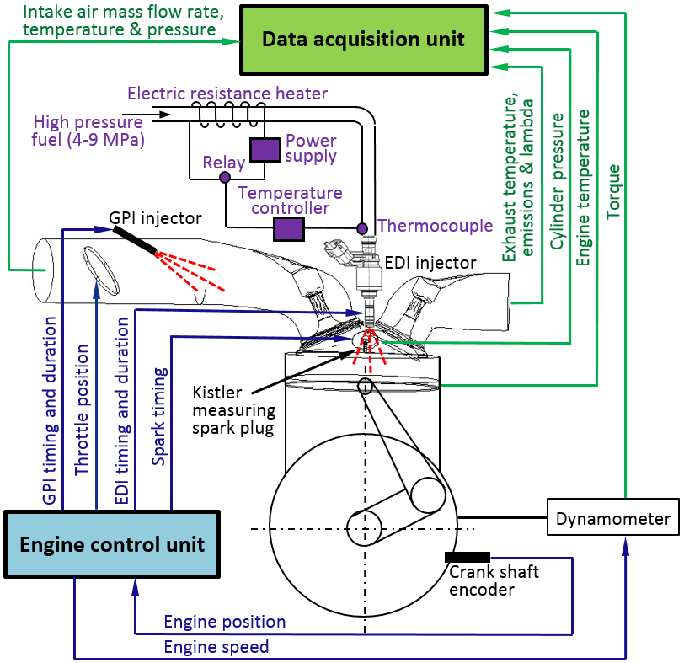
Fig. 1. Schematic of the EDI+GPI engine.

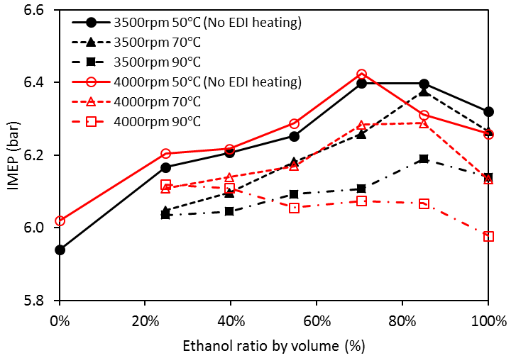
Fig. 2. Effect of ethanol fuel temperature on the IMEP.

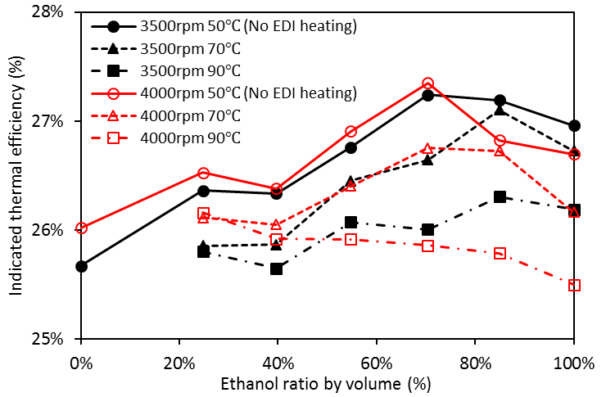
Fig. 3. Effect of ethanol fuel temperature on the indicated thermal efficiency.

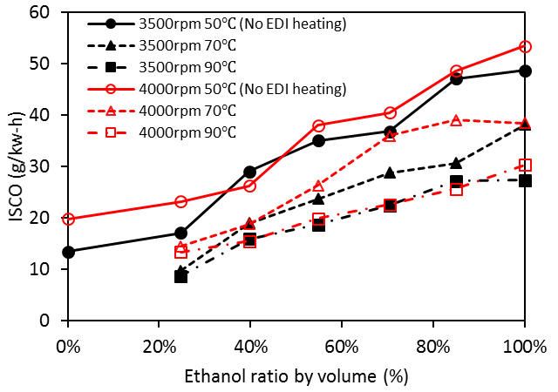
Fig. 4. Variation of ISCO with ethanol fuel temperature.

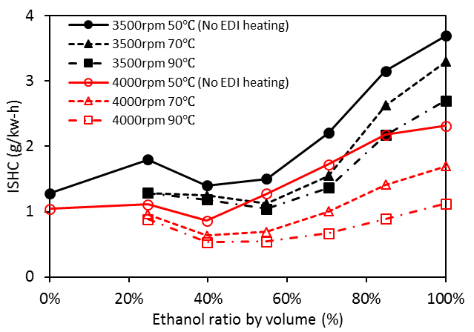
Fig. 5. Variation of ISHC with ethanol fuel temperature.

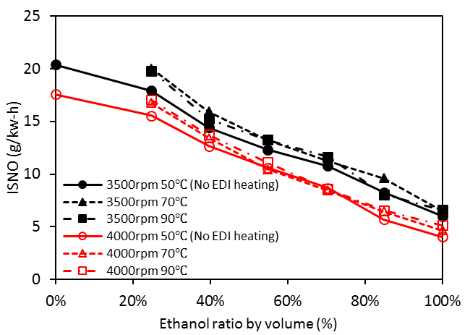
Fig. 6. Variation of ISNO with ethanol fuel temperature.

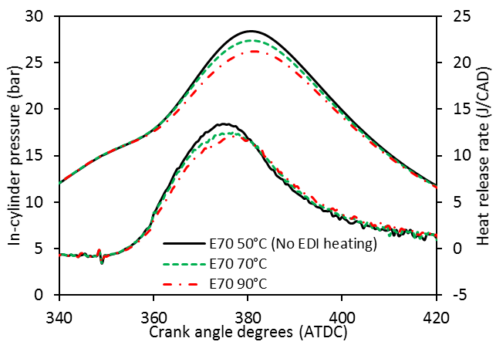
Fig. 7. Effect of ethanol fuel temperature on the in-cylinder pressure and heat release rate.

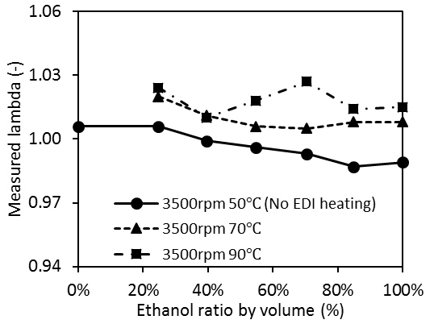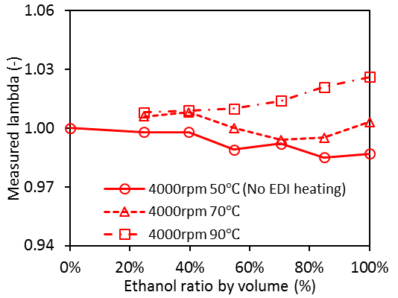
Fig. 8. Variation of lambda with ethanol fuel temperature.


(a) 52 ℃ (b) 77 ℃ (c) 92 ℃
Fig. 9. Effect fuel temperature on the EDI spray structure .

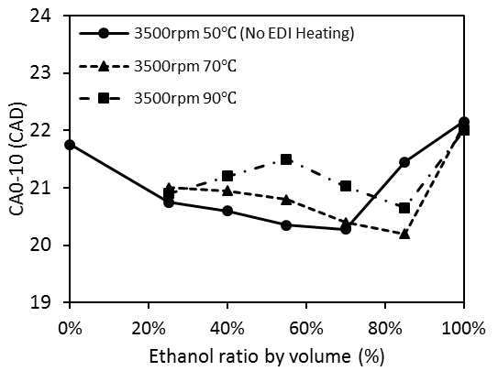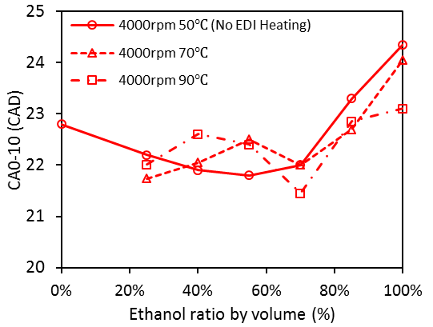
Fig. 10. Variation of CA0-10% with ethanol fuel temperature.

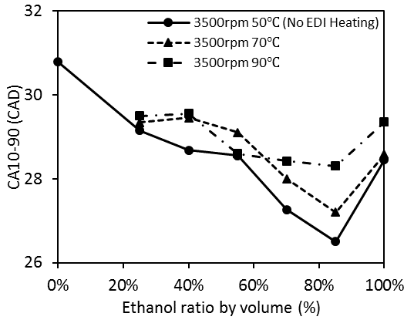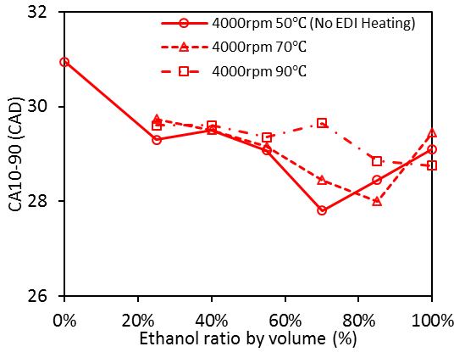
Fig. 11. Variation of CA10-90% with ethanol fuel temperature.

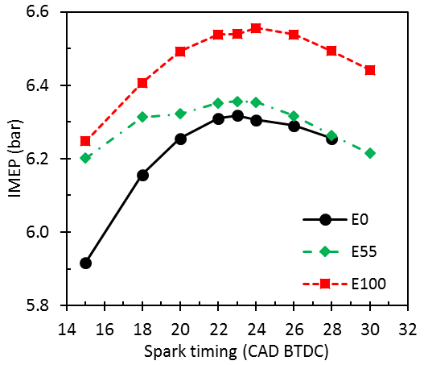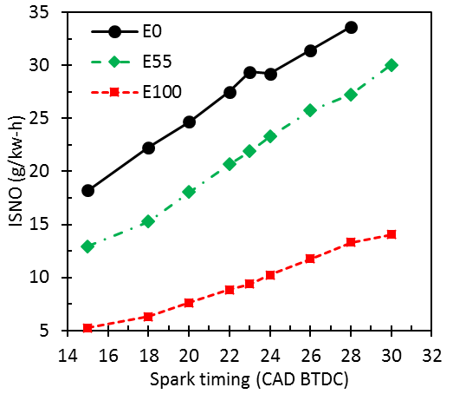
(a) (b)
Fig. 12. Effect of spark timing on IMEP (a) and NO emission (b) at ethanol ratios of 0%, 55% and 100%.

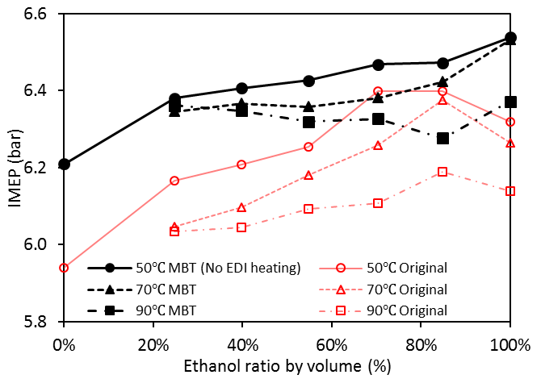
Fig. 13. Effect of EDI heating on IMEP at the MBT timing at various ethanol ratios.

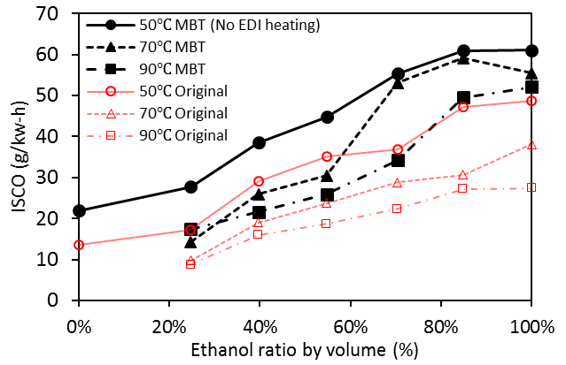
(a)
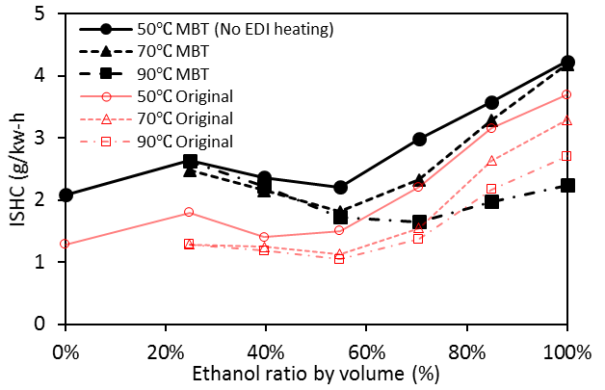
(b)
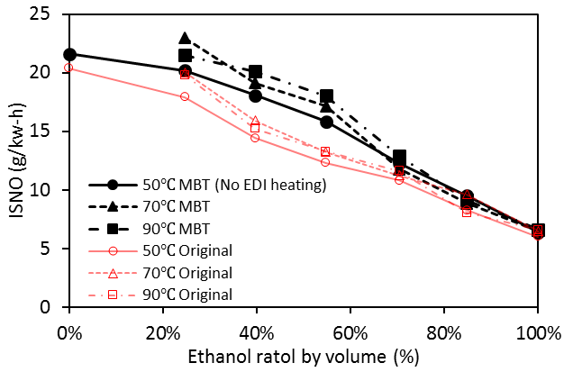
(c)
Fig. 14. Effect of EDI heating on ISCO (a), ISHC (b) and ISNO (c) at the MBT timing.

